Facility Assessment:
Facility and Community Risk

State logo added here. If not, delete text box

Facility Assessment: Facility-Based and Community-Based Risk Assessment

Reference F Tags

F838 §483.70(e) Facility assessment
§483.70(e)(3) A facility-based and community-based risk assessment, utilizing an all-hazards approach.

Guidance
The facility based and community-based risk assessment, utilizing an all-hazards approach must evaluate the facility’s ability to maintain continuity of operations and its ability to secure required supplies and resources during an emergency or natural disaster.
For example, if the facility is located in a flood zone, the risk assessment must include an evaluation of how residents will be kept safe and needs met during a flood affecting the facility.

Facility staff should consider involving their local/county Office of Emergency Preparedness when conducting this community based risk assessment. The facility’s emergency preparedness plans as required under §483.73 (Emergency Preparedness) should be integrated and compatible with the facility assessment. As one is updated, so should the other.

Risk Assessment is general terminology that is within the emergency preparedness regulations and preamble to the Final Rule (81 Fed. Reg. 63860, Sept. 16, 2016) which describes a process facilities are to use to assess and document potential hazards within their areas and the vulnerabilities and challenges which may impact the facility.

Additional terms currently used by the industry are all-hazards risk assessments, also referred to as Hazard Vulnerability Assessments (HVAs), or all-hazards self-assessments. For the purposes of these guidelines, we are using the term “risk assessment,” which may include a variety of current industry practices used to assess and document potential hazards and their impacts. Hazard Vulnerability Assessments (HVAs) are systematic approaches to identifying hazards or risks that are most likely to have an impact on a healthcare facility and the surrounding community. The HVA describes the process by which a provider or supplier will assess and identify potential gaps in its emergency plan(s).
Potential loss scenarios should be identified first during the risk assessment. Once a risk assessment has been conducted and a facility has identified the potential hazards/risks they may face, the organization can use those hazards/risks to conduct a Business Impact Analysis.

This guidance is not specifying which type of generally accepted emergency preparedness risk assessment facilities should have, as the language used in defining risk assessment activities is meant to be easily understood by all providers and suppliers that are affected by this final rule and is aligned with the national preparedness system and terminology (81 Fed. Reg. 63860, at 63875). However, facilities are expected to conduct a full assessment of hazards based on geographical location and the individual facility dynamics, such as patient population.

INTENT OF THE FACILITY-BASED AND COMMUNITY BASED-RISK ASSESSMENT

The intent of the all hazards approach to assessing risk, Facility-Based and Community-Based Risk Assessment is to assess and document potential hazards within the geographic area of the facility, the facility physical plant and the vulnerabilities and challenges that may impact the facility. The risk assessment will evaluate the facility’s ability to maintain continuity of operations, its ability to provide care and services, and its ability to secure required supplies and resources during an emergency or natural disaster. Based upon these assessments, the facility will identify hazards and risks for residents and that information shall be incorporated into the Facility Assessment and Emergency Preparedness Plan.

CMS DEFINITIONS

CMS’ Emergency Preparedness Appendix Z regulations contain specific terminology for which many providers requested clarification. The following definitions are contained in a Frequently Asked Questions (FAQs) document which can be downloaded from https://www.cms.gov/Medicare/Provider-Enrollment-and-Certification/SurveyCertEmergPrep/Emergency-Prep-Rule.html.

- “All-Hazards Approach” An all-hazards approach is an integrated approach to emergency preparedness planning that focuses on capacities and capabilities that are critical to preparedness for a full spectrum of emergencies or disasters, including internal emergencies and a man-made emergency (or both) or natural disaster. This approach is specific to the location of the provider or supplier and considers the particular type of hazards most likely to occur in their areas. These may include, but are not limited to, care-related emergencies, equipment and power failures, interruptions in communications, including cyber-attacks, loss of a portion or all of a facility, and interruptions in the normal supply of essentials such as water and food. Rather than managing planning initiatives for a multitude of threat scenarios all-hazards planning focuses on developing capacities and capabilities that are critical to preparedness for a full spectrum of emergencies or disasters. Thus, all-hazards planning does not specifically address every possible threat but ensures those hospitals and all other providers and suppliers will have the capacity to address a broad range of related emergencies.

FACILITY-BASED AND COMMUNITY BASED-RISK ASSESSMENT PROCESS
The facility based and community-based risk assessment process is a team approach. Led by the facility administrator, the team will utilize an all hazards approach to complete the risk assessment in conjunction with the facility Emergency Preparedness Plan. The purpose of an all hazards risk assessment is to assist facilities in identifying the greatest threats and vulnerabilities within the facility and the community. Based upon the assessment, the resource or knowledge gaps can be addressed, correlate the findings with the Facility Assessment and complete the Emergency Preparedness Plan.
The following process is recommended for the completion of the Facility-Risk and Community-Risk assessment:

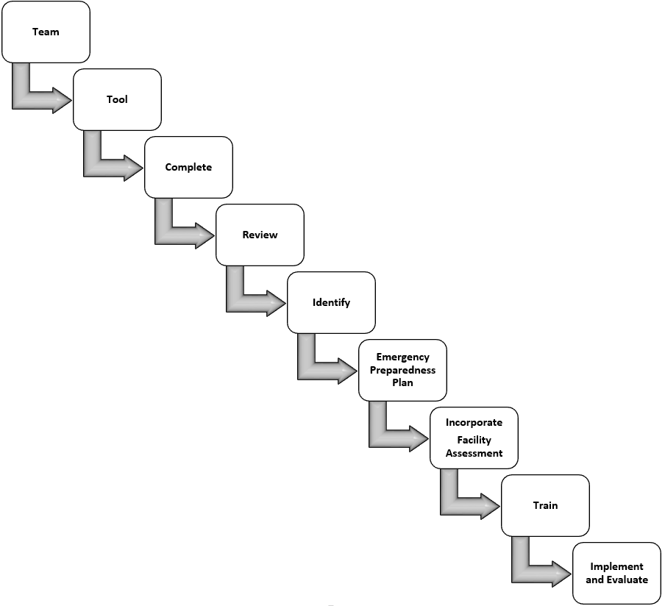

- Team
  - Assemble a team led by the facility Administrator
  - Specific team members as indicated and required
  - Possible inclusion local/county Office of Emergency Management and other organizations as appropriate
- Tool
  - Determine the all hazards tool for team completion
  - Recommend utilizing a Hazard Vulnerability Assessments (HVAs)
    - Purpose of the HVA is to assist the facility in identifying the greatest threats and vulnerabilities within your facility or local community, as well as using the tool to plan for emergencies and address resource gaps
- Complete
  - Complete the all hazards tool per guidelines

- Review
  - Review and analyze the findings of the HVA
  - Summarize the findings with the Team
  - Focus on potential high volume, high risk areas

- Identify
  - Identify Hazards
    - Hazards that may cause:
      - Injury
      - Property damage
      - Business disruption
      - Environmental impact
  - Identify Vulnerabilities
  - Determine potential Business Impact
    - Lost revenue and billing capabilities
    - Labor costs – overtime and accessibility
    - Third party agreements and contingencies
    - Regulatory implications
    - Recovery strategies and costs
    - Identification, document and recovery needs of key business functions and processes
    - Potential relocation plan (See Admission, transfer, discharge policies)
    - Insurance policies
  - Community risk may include:
    - Knowledge and skill of your community and of yourself as a provider in the community
    - Knowledge of the facility’s consumers and local community residents
    - Knowledge of the facility’s capacity and capabilities
  - Determine and implement necessary actions related to hazards and vulnerabilities that are not addressed in the Emergency Preparedness Plan

- Emergency Preparedness
  - Plans for should identify threats or hazards, opportunities for prevention and risk mitigation

- Incorporate into Facility Assessment
  - Incorporate findings into the applicable sections of the written narrative Facility Assessment
  - Refer to the Risk Assessment of the Emergency Preparedness Plan

- Train
  - Provide training to all staff as required
  - Provide training to facility leadership as it relates to their respective roles and responsibilities *See facility Emergency Preparedness Plan

- Implement and Evaluate
  - Follow Emergency Preparedness Plan drill and implementation requirements
  - The findings of the risk assessment should be integrated and compatible with the Facility Assessment and the Emergency Preparedness Plan.
    - As one is updated, so should the other.
  - The Facility Assessment, including the all hazards risk assessment, should be reviewed annually or updated per requirements

HOW TO INCORPORATE INTO THE FACILITY ASSESSMENT

Per §483.70(e)(3) the facility assessment must include or address an facility-based and community-based risk assessment, utilizing an all-hazards approach. Therefore, it is important to:
- Gather the outcomes data related to the all hazards approach risk assessment as described above.

- Use the information to answer the questions:
  - Has the facility identified potential hazards that may impede resident care delivery, day to day operations or operations during an emergency situation?
  - Has the facility identified potential vulnerabilities that may impede resident care delivery, day to day operations or operations during an emergency situation
  - Has the facility determined the business impact of an emergency and incorporated a plan into the Emergency Preparedness Plan?
  - Has the facility identified the resource or knowledge gaps and correlate the findings with the Facility Assessment and complete the Emergency Preparedness Plan?

- Incorporate your processes into your QAPI plan.

- Monitor the facility assessment annually or upon a change in the facility’s operation that would require a substantial modification in the assessment and adjust the facility training plan accordingly.

- Write a narrative description of the facility’s facility-based and community-based risk assessment for inclusion, see below, into the narrative Facility Assessment. See the Facility Assessment Template.

- It is acceptable to refer to the risk assessment including in the emergency preparedness plan pursuant to 483.75

See the Facility Assessment Template SAMPLE related to the inclusion of the necessary information obtained via this process for the completion of the Facility Assessment.

References

State Operations Manual (SOM) Appendix PP for Phase 2, F-Tag Revisions, and Related Issues
www.cms.gov/Medicare/Provider-Enrollment-and-Certification/GuidanceforLawsAndRegulations/Downloads/Advance-Appendix-PP-Including-Phase-2-.pdf

CMS Ref: S&C 17-29-ALL Advanced Copy – Appendix Z, Emergency Preparedness Final Rule Interpretive Guidelines and Survey Procedures https://www.cms.gov/Medicare/Provider-Enrollment-and-Certification/SurveyCertificationGenInfo/Downloads/Survey-and-Cert-Letter-17-29.pdf
Quality Improvement Organizations, Facility Assessment Tool (2017), http://qioprogram.org/facility-assessment-tool

