HAZARD VULNERABILITY ASSESSMENT
Hazard identification and risk assessment provides a step by step, factual basis for activities proposed in the identification of risks and strategies for hazard mitigation. Hazard vulnerability analysis (HVA) and risk assessment are systematic approaches to identifying hazards or risks that are most likely to have an impact on a healthcare facility and the surrounding community.
An effective risk assessment informs proposed actions by focusing attention and resources on the greatest risks. The four basic components of a risk assessment are:
- Hazard identification
- Profiling of hazard events Inventory of assets
- Estimation of potential human and economic losses based on the exposure and vulnerability of people, buildings, and infrastructure.

There are multiple tools (HVA’s) and resources available to help facilities prioritize their planning efforts based on these identified hazards. Each state, through their Emergency Preparedness Coalition has tools, resources and training available for health care organizations.
Hazard Vulnerability Analysis Tool Examples
Kaiser Permanente has developed a Hazard Vulnerability Analysis tool which is available as a downloadable planning resource. Organizations using this tool are solely responsible for any hazard assessment, compliance with applicable regulations and laws as well as facility identification of hazards and vulnerabilities. This tool It can be accessed at:
The U.S. Department of Health & Human Services at
https://asprtracie.hhs.gov/technical-resources/resource/250/kaiser-permanente-hazard-vulnerability-analysis-hva-tool

The Kaiser Permanente HVA tool, depicted below, is downloadable and customizable for your individual organization’s needs.
1. Fill in facility specific information
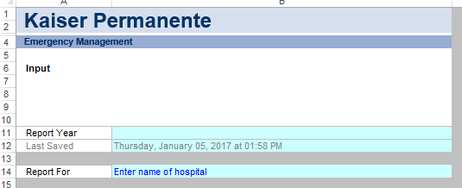
2. Conduct your analysis with your team and complete the data collection section – including the type of hazard, impact, probability, response and risk level.
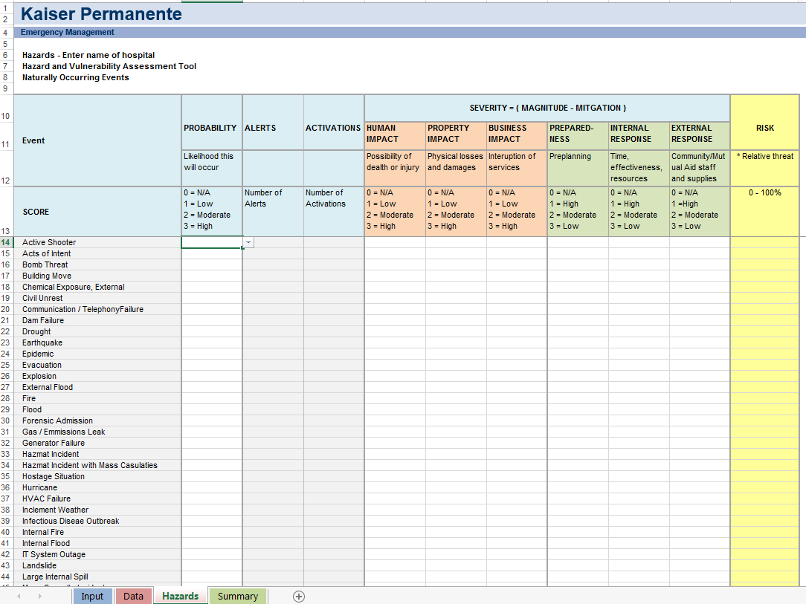
3. Summarizes your individual facility information, identifying the specific trends as required.
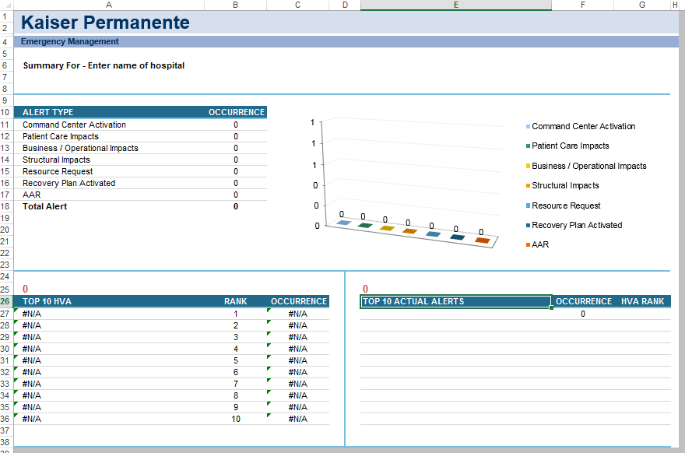

4. Should an incident occur, it provides a log to document your organization’s response and correlates back to your HVA analysis.
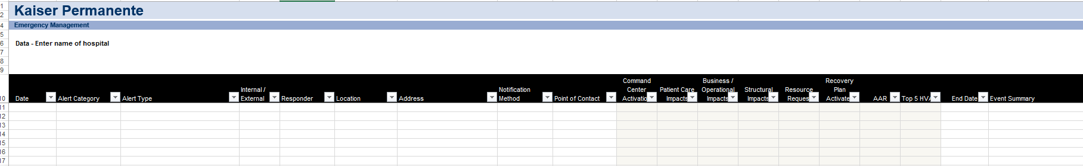
ACCESS STATE AND LOCAL SPECIFIC RESOURCES
All State Health Care Coalition Listing
https://www.cms.gov/Medicare/Provider-Enrollment-and-Certification/SurveyCertEmergPrep/Downloads/By-Name-by-State-Healthcare-Coalitions.pdf
Additional Resources related to HVA
U.S. Department of Health & Human Services – Emergency Response
https://asprtracie.hhs.gov/technical-resources

Long Term Care HVA Resources
Department of Health and Human Services
https://asprtracie.hhs.gov/technical-resources/52/long-term-care-facilities/47

