**Facility Assessment Template**

* Order of Information
* Introduction
  + Intent
  + Facility Assessment Process
  + Facility Assessment and QAPI
* Facility Overview
  + Facility Description
  + Resident Profile
* Resident Demographics
  + Caring for Residents with Conditions not listed above
  + Resident Population Acuity
  + Resident Level of Independence to Dependence
  + Resident Preferences
  + Resident Care and Services Correlating to Resident Population

## Facility Resources

## Facility Staff

## Staffing Plan

## Staff Education, Training and Competencies

* + Policies and Procedures for provision of care
* Resources for Resident Population Needs
  + Equipment, Supplies, Additional Services and Third Party Arrangements
* Health Information Technology
* Infection Control
* Facility and Community Risk Assessment
* Summary

**<< INSERT LOGO or NAME Of FACILITY>>**

**FACILITY ASSESSMENT**

|  |  |
| --- | --- |
| Team Members | *(Reminder required members are: Administrator, Director of Nursing, Medical Director, Governing Body rep)* |
| Assessment Completed |  |
| QAA/QAPI Review Completed |  |

**Introduction**

The Facility Assessment is required by the nursing home Requirements of Participation to identify and analyze the facility’s resident population and identify the personnel, physical plant, environmental and emergency response resources to needed to competently care for the residents during day to day operations and emergencies.

**Intent**

The facility provides person-centered, competent care that helps each person served to live their lives as they wish. The services and care provided assist people to reach their highest level of practicable potential and maintain their ability to participate in life activities as long as they are able. The facility offers comfort and compassionate care to those at the end of their lives.

*((Insert facility Mission or Philosophy of care))*

The facility assessment serves as a resource to support decision-making regarding staffing and other resources.

*((Describe what you will do with the Facility Assessment – modify as needed – the language follows the requirements))*

The Facility Assessment collects information about the facility’s resident population to identify the number of residents; facility capacity; the care required; staff competencies; the ethnic, cultural and religious aspects of the unique resident population; physical; personnel resources needed; contractual agreements; health information technology resources; environment; equipment, supplies and other services utilized; and a facility and community based risk assessment utilizing an all hazards approach. The facility’s resources are identified and evaluated to ensure that care can be provided to meet residents’ needs during day to day and emergency operations.

## Facility Assessment Process

A Representative from the Governing Body, the Administrator, the Medical Director, Director of the Nursing, *((Describe who developed the Facility Assessment and what was the process utilized Therapy, Social Work Services, Nutrition Services, Activity Services and Environmental Services departments))* collaborated to develop and conduct the facility assessment with input from staff in each department.

Each department identified the relevant information to identify the resident population and the resources available within their departments to meet the residents’ needs.

Information sources such as *((Insert examples of data used to develop the Facility Assessment i.e. the average daily census, CMS Resident Census and Condition report Quality Measure Facility Characteristics Report, Diagnosis reports, Facility equipment inventory, staff orientation plan and annual training plan, and others))* were used to develop the Facility Assessment.

The Facility Assessment will be reviewed annually and if the resident population changes, new types of care and services are provided or new technology, equipment or other resources are introduced.

## Facility Assessment and QAPI

Information from the Facility Assessment is used to inform the Quality Assurance Performance Improvement (QAPI) process as indicated in the QAPI Plan. The identification of residents needs focuses the activities of the QAPI process. The description of care, services and resources available at the facility provides both areas for monitoring of processes and outcomes as well as information for investigation of root causes of adverse events and gaps in performance.

*((Insert specific information related to QAPI process and correlation to*

*Facility Assessment or modify the above))*

## FACILITY OVERVIEW

## Facility Description

*((facility name))* is a licensed *((skilled nursing, ….))* facility. The facility is licensed for __________ beds with an average daily census of __________. The facility provides *(((indicate or differentiate either by number or % - short term, long stay, memory care, specialty programming i.e. vents, bariatric,* *cardio rehab, ACO, etc)) .*

*((Example - The facility has 100 beds available for resident use and has an average census of 80 residents. There is a 20 bed secured Memory Care unit and a 20 bed Short Term Transitional Care unit as well as 40 beds for long stay residents))*

The facility admits approximately _____ individuals and discharges _______ individuals on a monthly basis with an average length of stay of _______ days. Our average RUG level for the facility is ________. *((if applicable - separate out RUG level for specialty programs))*

The facility is located *((description of acreage, special location in community, etc))* with ((# of buildings, structures)), ((number of units or households)). Our facility also provides *((insert information on transportation vans, vehicles, walking trails, swimming pool, clinic, …)*

*((Insert facility specific description of the facility or campus and surrounding area))*

**Resident Profile**

The facility serves individuals who often times have one or more chronic or co-morbid conditions. Our overall resident population consists of …

*((Insert a Narrative overview of your resident population. See examples of resident population description on Facility Template with Instructions))*

* **Resident Demographics – Diseases, conditions, physical and cognitive disabilities**

The following indicates the common diagnosis/conditions, physical and cognitive disabilities or a combination of these conditions. *((list top 10 conditions based on category))*

| **Category (system)** | **Common Diagnosis** | **% of Population** |
| --- | --- | --- |
|  |  |  |
|  |  |  |
|  |  |  |
|  |  |  |
|  |  |  |
|  |  |  |
|  |  |  |
|  |  |  |
|  |  |  |
|  |  |  |

***\*Data Source*** *– (( insert specific summary statement i.e. The information about the resident population was derived from the CMS 672 Resident Census and Condition report, the CMS Quality Measure Facility Characteristics report, diagnosis and condition and MDS reports from the electronic health record))*

* **Caring for Residents with Conditions not listed above**

Although the list above depicts the top common diseases and conditions that we serve, our facility has a comprehensive process in place to assess resident needs and determine the care and services required. The facility cares for residents with skilled needs. We utilize a comprehensive admission, readmission and required assessment process in which the interdisciplinary team identifies individualized resident care needs.

*((Modify for your facility and population you serve))*

Should an individual require care and services based upon a diagnosis or condition not typically serviced in our resident population, our team, in conjunction with our Medical Director and Director of Nursing… ((insert facility process))

* **Resident Population Acuity**

The facility reviews acuity within our resident population. The below outlines the resident population acuity within the past _______ months.

*((the facility may wish to complete two grids if there are*

*specific specialty programs which may alter the %))*

|  |  |
| --- | --- |
| **RUG IV** | **% of Population** |
|  |  |
|  |  |
|  |  |
|  |  |
|  |  |
|  |  |
|  |  |

* **Resident Level of Independence to Dependence**

| **ADL Assistance** | **Independent %** | **Assist of 1-2 %** | **Dependent %** |
| --- | --- | --- | --- |
| Dressing |  |  |  |
| Bathing |  |  |  |
| Transfer |  |  |  |
| Eating |  |  |  |
| Toileting |  |  |  |
|  | **Independent %** | **Asst Device Used to Ambulate** | **In Chair Most of Time** |
| Mobility |  |  |  |

***\*Data Source*** *– ((Insert Summary statement – i.e. The information about the resident population was derived from the CMS 672 Resident Census and Condition report, the CMS Quality Measure Facility Characteristics report, diagnosis and condition and MDS reports from the electronic health record))*

* **Resident Preferences**

The facility supports a culture of person centered care with respect to personal preferences. Our facility support this by our admission process as well as our day to day operations…

*((Indicate how your facility supports preferences – activities, food, space. Describe other pertinent facts or descriptions of the resident population that must be taken into account))*

## Resident Care and Services Correlating to Resident Population

The facility provides care and services based upon the needs of our resident population. Our facility embraces a person-centered care culture in which we provide care and services based upon our resident population, including the following:

((See example statements in the Facility Assessment Template with Instructions))

*((Modify based upon resident population))*

* + Assistance with activities of daily living
  + Mobility assistance
  + Incontinence prevention and care
  + Medications and Medication Management
  + Intravenous Therapy
  + Behavioral health
  + Psycho social support
  + Clinical System - Pain, Wound Care, Pain Management…..
  + Infection Control
  + Rehabilitation
  + Respiratory Therapy
  + Therapeutic Recreation
  + Special Care Needs including: _____________
  + Nutrition

## Facility Resources

## Facility Staff

The facility is managed by *((insert specific information -governing body, a Board of Directors, etc))* and Administrator. The Medical Director oversees medical practice and the clinical policies and programs of the facility. Each resident is supported to choose their own physician. There are ___ physicians and ____ nurse practitioners that visit the facility regularly to see residents. The facility collaborates medical practitioners as it relates to the care and service needs of the facility resident population.

*((Insert overview organization chart if applicable))*

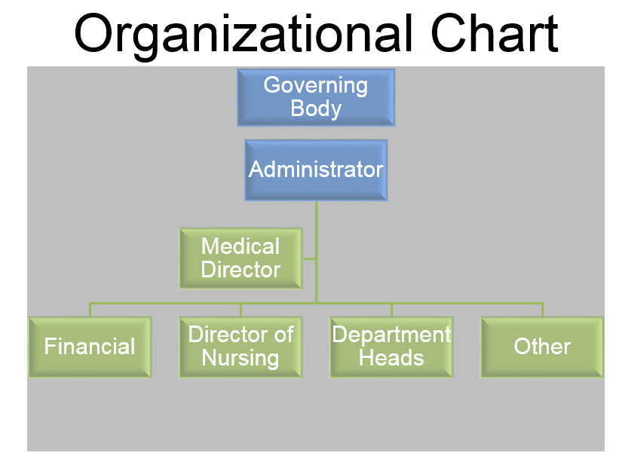

The facility personnel consist of: *((insert specific information))*

* licensed nurses, RN and LPN, certified nursing assistants, medication technicians,
* medical records staff,
* licensed social workers,
* a registered dietician and
* nutrition services staff,
* activities staff,
* maintenance, housekeeping and laundry staff, and
* staff in the business office.
* Each department is led by a department director.
* Therapy services are provided under contract and staff includes, licensed physical and occupational therapists and speech language pathologists.
* Volunteers
* Pharmacist
* Behavioral Health providers
* Support services
* Laboratory
* Diagnostic Services
* Other

## Staffing Plan

The table below describes the number of staff available to meet residents’ needs. Nursing, nutrition services and housekeeping staffing is evaluated at the beginning of each sift and adjusted as needed to meet the care needs and acuity of the resident population. Please see the posted nursing staffing hours for details.

*((insert specific information))*

|  |  |
| --- | --- |
| **Position** | **FTEs** |
| Licensed nurses |  |
| Certified nursing assistants |  |
| Medication techs |  |
| Restorative nursing assistants |  |
| Licensed social worker |  |
| Dietician |  |
| Nutrition services staff |  |
| Social Services |  |
| Activity Therapy |  |
| Other Services |  |

Nursing staff is primarily assigned to care for the same residents. There are a few nursing staff who move between two primary units to fill in vacancies.

((Insert Information -Describe how staff assignments are assigned for continuity of care))

## Staff Education, Training and Competencies

Each job description identifies the required education and credentials for the job. Staff education and credentials are verified prior to hire.

Every staff member has knowledge competency in: *((insert specific information))* abuse, neglect, exploitation and misappropriation; resident rights; identification of condition change; and resident preferences. Additional knowledge competencies for all staff include dementia management, infection transmission and prevention, immunization, QAPI, and OSHA hazard communication. Hand hygiene return demonstration competencies and observed knowledge competencies for emergency response are also required.

Additional competencies are determined according to the amount of resident interaction required by the job role, job specific knowledge, skills and abilities and those needed to care for the resident population.

Certified nursing assistants have additional required competencies for *((insert specific information))*

|  |
| --- |
| Person centered care |
| * *Communication* |
| * *Basic nursing skills* |
| * *Basic restorative services* |
| * *Skin and wound care* |
| * *Medication management* |
| * *Pain management* |
| * *Additional Infection control topics* |
| * *Identification of changes in condition* |
| * *Cultural competency* |

Competencies are based on current standards of practice and may include knowledge and a test, knowledge and return demonstration, knowledge and observed ability, knowledge and observed behavior and annual performance evaluation. Competencies are based on the care and services needed by the resident population. Please see the Resident Needs and Competencies worksheet for more details

Competencies are verified upon orientation, least annually and as needed.

*((Modify and insert specific information))*

The facility provides education and training *(( insert if in person, self directed, on line – what system, in-service…))* The staff training and education program is designed to ensure knowledge competency for all staff. Education is provided through the on-line learning system, peer mentoring and classroom sessions. The training program is reviewed and revised each time the Facility Assessment is reviewed and/or revised.

**Policies and Procedures for Provision of Care**

The care needs of the residents and the requirements of regulations rules and laws govern the needed policies and procedures.

*((Modify and insert specific information))*

Policies and procedures for care are reviewed and updated at least annually and as needed with the introduction of new resident care needs, new technology or equipment or a change in the physical plant or environmental hazards.

**Resources for Resident Population Needs**

*Equipment, Supplies, Additional Services and Third Party Arrangements*

Via a prescribed process, the facility evaluates the day to day and emergency provision of equipment (medical and non-medical), supplies, as well as additional services by providers via a contractual arrangement which is based upon the resident population care needs, annually or as needed. The following steps are utilized throughout the evaluation process:

*((Modify and insert specific information))*



This process is conducted in conjunction with the facility assessment evaluation, per requirement, and the facility QAPI process.

Upon the evaluation process, it has been determined that the type and number of resources (i.e. equipment, supplies, other services) is adequate to meet the resident population care needs and services daily. The facility has reviewed the provision of resources in an emergency and determined that the type and number of resources, services and supplies are planned and applicable to the resident population. See the Emergency Preparedness Plan.

**Equipment and Supplies**

The facility has a designee who oversees the procurement and maintenance of par levels for resident equipment and supplies based upon resident population needs.

*((Modify and insert specific information))*

*((insert facility specific information – describing the facility process which reviews resident needs, par levels for adequate supplies and equipment))*

The facility utilizes the Preventative Maintenance Program to inventory equipment, physical plant and other physical plant needs and conduct maintenance prevention based upon the PMP plan.

*((Modify and insert specific information))*

The facility evaluates the physical environment, equipment (medical and non-medical), supplies, and additional services by providers via a contractual arrangement based upon the resident population needs for provision of care, annually or as needed.

**Third Party Agreements, Contracts, Memoranda of Understanding**

Under the direction of the Administrator, the facility reviews all third-party agreements, contracts, and memoranda of understandings via a prescribed process which reviews the vendor arrangement, terms of contract and the provision of services on a daily or emergency need. These arrangements for the provision of services, equipment, and supplies to provide the level and types of care needed for the resident population.

*((Modify and insert specific information))*

**Health Information Technology**

The facility has a designee who oversees the health information technology resources including electronic health records and electronic sharing of resident information. The facility has a system to

*((insert facility specific information as it relates to interoperability, security, how information is exchanged with other providers – home care, assisted living, acute, physicians, receiving facility and resident/resident representative access of information))*

**Infection Control**

The facility has conducted an infection control risk assessment which evaluated and determined the risk or potential vulnerabilities within the resident population and the surrounding community. This process is integrated with the facility Infection Prevention and Control Program (IPCP). The IPCP is designed to meet current standards of practice and the needs of the facility population, staff and community. It is part of the QAPI program. The IPCP is reviewed at least annually and whenever the Facility Assessment is reviewed.

*((Modify and insert specific information))*

**Facility and Community Risk Assessment**

The facility has conducted a facility and community based risk assessment which document potential hazards within the geographic area of the facility, the facility physical plant and the vulnerabilities and challenges that may impact the facility utilizing an all hazards approach. In addition, the risk assessment evaluates the facility’s ability to maintain continuity of operations, its ability to provide care and services, and its ability to secure required supplies and resources during an emergency or natural disaster. This risk assessment has been in incorporated Emergency Preparedness Plan.

*((Modify and insert specific information))*

**Summary**

In summary, the facility

((Insert ending summary statement if applicable or desired))