QUALITY ASSURANCE PERFORMANCE IMPROVEMENT PROGRAM
Preface

Per the QAPI New Brief published by CMS in 2013, Quality Assurance Performance Improvement (QAPI) is the merger of two approaches to monitor and improve quality.

Quality Assurance is a process of meeting quality standards and assuring that care reaches an acceptable level. Nursing homes typically set QA thresholds to comply with regulations. They may also create standards that go beyond regulations. QA is a reactive, retrospective effort to examine why a facility failed to meet certain standards. QA activities do improve quality, but efforts frequently end once the standard is met.

PI (also called Quality Improvement - QI) is a proactive and continuous study of processes with the intent to prevent or decrease the likelihood of problems by identifying areas of opportunity and testing new approaches to fix underlying causes of persistent/systemic problems. PI in nursing homes aims to improve processes involved in health care delivery and resident quality of life. PI can make good quality even better
Regulations require that a facility’s QAPI program be ongoing, comprehensive and address the full range of care and services provided by the facility. The program must address all systems of care and management practices. The program utilizes the best available evidence to define and measure indicators of clinical care, quality of life, resident choice. The facility’s goals reflect care processes and facility operations that have been shown to be predictive of desired outcomes for residents of SNFs and NFs. The program reflects each facility’s complexities, unique residents and care and services provided.
A comprehensive QAPI program involves all staff. Residents and residents’ representatives are knowledgeable of the facility’s QAPI activities.

Regulations

§483.75(a) Quality assurance and performance improvement (QAPI) program.

Each LTC facility, including a facility that is part of a multiunit chain, must develop, implement, and maintain an effective, comprehensive, data-driven QAPI program that focuses on indicators of the outcomes of care and quality of life. The facility must:

(1) Maintain documentation and demonstrate evidence of its ongoing QAPI program that meets the requirements of this section. This may include but is not limited to systems and reports demonstrating systematic identification, reporting, investigation, analysis, and prevention of adverse events; and documentation demonstrating the development, implementation, and evaluation of corrective actions or performance improvement activities;

(2) Present its QAPI plan to the State Survey Agency no later than 1 year after the promulgation of this regulation; [§483.75(a)(2) will be implemented beginning November 28, 2017 (Phase 2)]

(3) Present its QAPI plan to a State Survey Agency or Federal surveyor at each annual recertification survey and upon request during any other survey and to CMS upon request; and
(4) Present documentation and evidence of its ongoing QAPI program's implementation and the facility's compliance with requirements to a State Survey Agency, Federal surveyor or CMS upon request.
§483.75(b) Program design and scope.
A facility must design its QAPI program to be ongoing, comprehensive, and to address the full range of care and services provided by the facility. It must:
(1) Address all systems of care and management practices;
(2) Include clinical care, quality of life, and resident choice;
(3) Utilize the best available evidence to define and measure indicators of quality and facility goals that reflect processes of care and facility operations that have been shown to be predictive of desired outcomes for residents of a SNF or NF.
(4) Reflect the complexities, unique care, and services that the facility provides.

§483.75(c) Program feedback, data systems and monitoring.
A facility must establish and implement written policies and procedures for feedback, data collections systems, and monitoring, including adverse event monitoring. The policies and procedures must include, at a minimum, the following:
(1) Facility maintenance of effective systems to obtain and use of feedback and input from direct care staff, other staff, residents, and resident representatives, including how such information will be used to identify problems that are high risk, high volume, or problem-prone, and opportunities for improvement.
(2) Facility maintenance of effective systems to identify, collect, and use data and information from all departments, including but not limited to the facility assessment required at §483.70(e) and including how such information will be used to develop and monitor performance indicators.
(3) Facility development, monitoring, and evaluation of performance indicators, including the methodology and frequency for such development, monitoring, and evaluation.
(4) Facility adverse event monitoring, including the methods by which the facility will systematically identify, report, track, investigate, analyze and use data and information relating to adverse events in the facility, including how the facility will use the data to develop activities to prevent adverse events.

§483.75 (d) Program systematic analysis and systemic action.
(§483.75 (d) will be implemented during Phase 3)
(1) The facility must take actions aimed at performance improvement and, after implementing those actions, measure its success, and track performance to ensure that improvements are realized and sustained.
(2) The facility will develop and implement policies addressing: (i) How they will use a systematic approach to determine underlying causes of problems impacting larger systems;
(ii) How they will develop corrective actions that will be designed to effect change at the systems level to prevent quality of care, quality of life, or safety problems; and
(iii) How the facility will monitor the effectiveness of its performance improvement activities to ensure that improvements are sustained.

§483.75(e) Program activities.
(1) The facility must set priorities for its performance improvement activities that focus on high-risk, high-volume, or problem-prone areas; consider the incidence, prevalence, and severity of problems in those areas; and affect health outcomes, resident safety, resident autonomy, resident choice, and quality of care.
(2) Performance improvement activities must track medical errors and adverse resident events, analyze their causes, and implement preventive actions and mechanisms that include feedback and learning throughout the facility.
(3) As part of their performance improvement activities, the facility must conduct distinct performance improvement projects. The number and frequency of improvement projects conducted by the facility must reflect the scope and complexity of the facility's services and available resources, as reflected in the facility assessment required at §483.70(e). Improvement projects must include at least annually a project that focuses on high risk or problem-prone areas identified through the data collection and analysis described in paragraphs (c) and (d) of this section
§483.75(f) Governance and leadership.
The governing body and/or executive leadership (or organized group or individual who assumes full legal authority and responsibility for operation of the facility) is responsible and accountable for ensuring that:
(1) An ongoing QAPI program is defined, implemented, and maintained and addresses identified priorities.
(2) The QAPI program is sustained during transitions in leadership and staffing;
(3) The QAPI program is adequately resourced, including ensuring staff time, equipment, and technical training as needed;
(4) The QAPI program identifies and prioritizes problems and opportunities that reflect organizational process, functions, and services provided to residents based on performance indicator data, and resident and staff input, and other information.
(5) Corrective actions address gaps in systems, and are evaluated for effectiveness; and
(6) Clear expectations are set around safety, quality, rights, choice, and respect.

§483.75(g) Quality assessment and assurance.
[§483.75(g)(1)(i)-(iii) will be implemented beginning November 28, 2016 (Phase 1)]
(1) A facility must maintain a quality assessment and assurance committee consisting at a minimum of:
(i) The director of nursing services;
(ii) The Medical Director or his/her designee;
(iii) At least three other members of the facility's staff, at least one of who must be the administrator, owner, a board member or other individual in a leadership role; and
(iv) The infection control and prevention officer.
(2) The quality assessment and assurance committee reports to the facility's governing body, or designated person(s) functioning as a governing body regarding its activities, including implementation of the QAPI program required under paragraphs (a) through (e) of this section. The committee must:
(i) Meet at least quarterly and as needed to coordinate and evaluate activities under the QAPI program, such as identifying issues with respect to which quality assessment and assurance activities, including performance improvement projects required under the QAPI program, are necessary
(ii) Develop and implement appropriate plans of action to correct identified quality deficiencies;
(iii) Regularly review and analyze data, including data collected under the QAPI program and data resulting from drug regimen reviews, and act on available data to make improvements.
§483.75(h) Disclosure of information.
A State or the Secretary may not require disclosure of the records of such committee except in so far as such disclosure is related to the compliance of such committee with the requirements of this section.
§483.75(i) Sanctions.
Good faith attempts by the committee to identify and correct quality deficiencies will not be used as a basis for sanctions.
[§483.75(h)(i)) will be implemented beginning November 28, 2016 (Phase 1)]

Definitions

• “Quality Assessment” is an evaluation of a process and/or outcomes of a process to determine if a defined standard of quality is being achieved.

• “Quality Assurance” is the organizational structure, processes, and procedures designed to ensure that care practices are consistently applied and the facility meets or exceeds an expected standard of quality. Quality assurance includes the implementation of principles of continuous quality improvement.

• “Quality Deficiencies” are potential markers of quality that the facility considers to be in need of investigating and which, after investigation, may or may not represent a deviation from quality that results in a potential or actual undesirable outcome. The term “quality deficiency” in this regulation is meant to describe a deficit or an area for improvement. This term is not synonymous with a deficiency cited by surveyors.

• “Quality Improvement (QI)” is an ongoing interdisciplinary process that is designed to improve the delivery of services and resident outcomes

Sample
ABC Facility
Quality Assurance/Assessment and Performance Improvement Plan
Purpose
Example: The Quality Assurance/Assessment and Performance Improvement (QAPI) Program is to utilize an on-going, data driven, pro-active approach to advance the quality of life and quality of care for all residents at ABC Facility. Quality Assurance and Performance Improvement principles will drive our facilities decision making to promote excellence in all resident and staff related areas. All facility staff, families and residents will be encouraged to be involved in identifying opportunities for improvement, partake in QAPI teams, imbed QAPI activities in all core processes and provide ongoing feedback.
Mission
Example: To provide superior quality health care services and to be the facility of choice where our clients see themselves not as patients but rather as members of our extended family
Vision
Example: To be recognized leaders for excellence in healthcare with innovative services for improved resident and client outcomes.

Guiding Principles
Guiding Principle #1: Our organization makes quality improvement decisions based on data analysis with input from residents, families, staff and the community
Guiding Principle #2: Our organization uses quality assurance and performance improvement (QAPI) principles to address systems of care
Guiding Principle #3: In our organization, …
Guiding Principle #4:
Guiding Principle #5:

Design and Scope
Each facility’s program will be on-going, comprehensive and reflect the resident population, staff community, care and services provided by the facility and the resources available and reflect the Service Standards of ABC Facility.
Example: The QAPI program at ABC Facility encompasses post-acute care, long term care and outpatient therapy. The QAPI committee consists of representatives from all departments including nursing, food and nutrition, laundry, maintenance, health information technology, therapeutic recreation, therapy, business office and administration. Involvement will be varied by topic and may include committee, sub-committee or verbal/written input. Our service areas will work together to best meet the needs of the individuals living in our care center. All departments and services along with families, residents, volunteers, board members and contract staff will be educated on the principles of QAPI. All resident directed decisions will be focused on retaining autonomy, encouraging individualized choices and preserving the highest attainable quality of life and quality of care. PIPs will be implemented when an opportunity for improvement is identified. These PIPs may apply to processes or systems at all levels of the organization.
The QAPI program is ongoing, comprehensive and addresses the full range of care and services provided at ABC Facility.
Clinical Care – example: data will be obtained from the following reports: QI/QM, infection, medication error, pressure injuries, falls, health department surveys, CASPER and pain. Licensed nursing staff will receive up-to-date education on best practice and clinical guidelines to promote the highest attainable level of clinical care. The team will meet monthly with the Medical Director to achieve desirable outcomes for the residents. Results will be shared with the QAPI Steering Committee on a quarterly basis.
Quality of Life - example: the best available evidence will be utilized to define and measure indicators of quality including but not limited to resident and family satisfaction surveys, resident council meetings, health department surveys and grievances/concerns. The team will meet monthly to review findings and concerns, and prioritize activities. Results will be shared with the QAPI Steering Committee on a quarterly basis.
Resident Choice – example: individualized plans of care are developed with input from resident and family members. Plans of care are reviewed at care conferences and choices are offered with care options throughout the day. Residents or resident representatives are encouraged to direct their clinical care with staff member guidance to assure safety and informed decision making.
ABC Facility is unique in the population served as we have a ventilator unit with medically complex residents requiring nursing staff with specialized training. Education and competency training are performed on a regular basis. Other service areas include: memory care, short term rehab, long term care, hospice, and respite care.
The services available at ABC Facility include:

Skilled Nursing  Long-Term Care  Post-acute care  Dialysis  Hospice/Palliative Care  Pharmacy | Therapy  Outpatient  Physical  Occupational  Respiratory  Speech Language pathology  Alzheimer's/Memory Care  Skilled Rehabilitation
Dietary  Dining  Dietitian  Activities | Social Services  Care Coordination  Mental Health
Housekeeping  Laundry  Janitorial | Maintenance  Building  Landscaping/Grounds keeping  Equipment
Health Information Services  Electronic Health Record  Electronic Medical Record  Minimum Data Set | Business Office  Staffing  Billing  Human Resources
Organizational Resources include:
Staff Education
On-line LMS
On-boarding and Orientation
Internal Continuing Education
External Continuing Education, (Conferences, Symposiums, etc.)

Governance and Leadership
Example: The Nursing Home Administrator (NHA) and Board of Directors are responsible and accountable for the development, implementation and monitoring of the QAPI program.
- The Quality Assessment and Assurance (QAA) Committee consists of the Director of Nursing Services, the Medical Director, the Administrator, at least two other members of the facility staff, and the infection control and prevention officer.
- The QAA Committee meets at least quarterly to coordinate and evaluate the activities under the QAPI program.
- A QAPI Steering Committee is appointed by the NHA and the Executive leadership team and is interdisciplinary with at least two non-licensed staff who provide direct care or service to the residents. This may include nursing assistants, food and nutrition staff, housekeeping staff, maintenance and laundry staff.
- Non-licensed staff will serve on the Committee for one year and then rotate out so additional staff have the opportunity to service on the Committee.
- The QAPI Steering Committee, which includes the Medical Director as co-chair, meets monthly and is accountable for the continuous improvement in Quality of Life and Quality of Care. Minutes are recorded and shared with staff verbally and posted in staff areas for review.
- The QAPI Steering Committee collects data from sub committees (pain, falls, weight loss) and includes the data in their quarterly reports to the QAA Committee /NHA/Board of Directors.
- The QAA Committee completes an annual assessment of the program with report to the governing body/Board of Directors.
- A Quality Management Coordinator is appointed by the NHA and Executive Leadership team and is responsible for ongoing QAPI activities including development of a facility dashboard to display current goals and progress toward those goals.
- On a quarterly basis, the NHA will report on all current QAPI activities and outcomes to the Board of Directors.
- Annually, Executive Leadership will report on the status of the current QAPI plan and outline plans for the upcoming year. This information will be shared with the Board of Directors, management team, staff, and resident/family councils.
- The Executive Leadership team will support and advise the QAPI Steering Committee.
Budget: The Nursing Home Administrator works with the Board of Directors to create a budget for QAPI to assure that resources are available for the ongoing activities of the QAPI Committee. Resources include but are not limited to time for education, staff time for meetings, equipment, technology needs, software, supplies, improvement projects, etc. The NHA and Quality Management Coordinator will review the budget on a monthly basis and revise as necessary to assure ongoing success of the QAPI program.
Education: All staff including contracted staff are educated on the principles of QAPI. QAPI is included in orientation of new employees and in the annual education that all staff are required to attend. Education includes the use of visual aide tools, posters, pay-check stuffers, text alerts, small group exercises, department meetings, all staff meetings, change of shift reports, facility newsletter, etc. Staff will be trained on using QAPI principles, identifying areas for improvement, and how they can be involved in the QAPI process including participation on a PIP team. The QAPI program is sustained during transitions in leadership and staffing through all-staff education and involvement in the QAPI process.
Residents and families are also informed of the QAPI plan and are encouraged to share their insights, concerns and opportunities for improvement. QAPI will be discussed at resident council meetings and family council meetings. Involvement of residents and family members on a PIP team may be considered.
Culture: ABC Facility believes in providing a non-punitive environment where managers encourage all staff involvement in bringing forward concerns, areas for improvement, reporting mistakes, and reporting quality issues. Managers will respond respectfully and timely to maintain an environment where staff have no fear of reprisal.

Feedback, Data Systems, and Monitoring
Example: ABC Facility will monitor multiple data sources and performance indicators in determining areas of concern, gaps and opportunities and also to determine effectiveness of system modifications and other interventions. All data will be reviewed against state, national or organization benchmarks or thresholds as appropriate and will be reported to the Board of Directors on a quarterly basis.
Data for adverse events and medical errors will be tracked, causes analyzed and preventative actions and mechanisms put into place. Feedback will be provided to staff and education provided as needed.
Potential sources of data may include:
- Survey outcomes
- Complaints
- Near misses
- Input from staff, residents, families and volunteers
- CMS Quality Measures
- Medication Errors
- Rehospitalization Rates
- Staff hours per day
- Staff retention
- Case Mix findings
- Pharmacist reports
- CASPER report
- Behavioral Health reports
- Satisfaction survey outcomes
- Billing audits
- Five Star report
Data may be collected weekly, monthly or quarterly depending on frequency of data updates from each source. The QAPI Management Coordinator oversees the maintenance of the QAPI dashboard, monthly reports/graphs, QAPI logs, and minutes of all meetings. The QAPI Steering Committee will utilize CMS’s Measure/Indicator Development worksheet and CMS’s Measure/Indicator Collection and Monitoring Plan to assist with program development.
Insert facility specific table here with data source, frequency of data collection, who reviews the information and how the information is disseminated.

Performance Improvement Projects (PIPs)
Example: ABC Facility will review the designated sources of data; identify areas where gaps in performance may negatively affect resident or staff outcomes. Where opportunities for improvement are detected, the QAPI Steering Committee with input from the Leadership Team will prioritize focus areas for PIP development. In prioritizing activities, the team will consider:
- high-risk to residents and/or staff,
- high-volume or problem-prone areas,
- health outcomes,
- resident safety,
- resident autonomy,
- resident choice,
- cost,
- feasibility,
- relevance,
- responsiveness,
- areas not outside of benchmarks but of importance to the resident population we serve.
The CMS publication Prioritizing Worksheet for Performance Improvement Projects may be utilized to assist with prioritizing potential areas of concern.
At least annually a project that focuses on high risk or problem-prone areas will be addressed through the QAPI program including PIP development. As defined in the facility assessment required at §483.70(e) our facility’s services and resources will be taken into account when determining how many PIPs to support at one time. A minimum of one PIP and a maximum of four PIPs will occur simultaneously.
A project charter which establishes the goals, scope, timing, milestones, and team’s roles and responsibilities will be developed for each PIP. CMS’s form, Worksheet to Create a Performance Improvement Project Charter may be utilized by the QAPI Steering Committee to provide guidance to the PIP team.
The PIP team will be assembled by the QAPI Steering Committee and the QAPI Quality Manager. The team will be interdisciplinary with staff representing each job role affected by the project and may include resident and/or family representation when appropriate. Direct care staff will be replaced at their work station so that resident care is not interrupted. A project lead will be selected and will be responsible for coordinating, organizing and directing the activities of that specific PIP team.
The PIP Team will identify the information needed to evaluate the problem at hand, supplies required, staff participation, and any equipment needs. The project lead will communicate any identified resource needs to the QAPI Quality Manager. The team will utilize root cause analysis to identify the cause of the problem and any contributing factors. PDSA will also be used and is further described in the next section – Systematic Analysis and Systemic Action. The PIP team will develop an action plan with identified problem statement, causes, goals, interventions, staff responsible, and due dates.
The following forms may be utilized for PIP Action Plans:
Insert facility specific form here
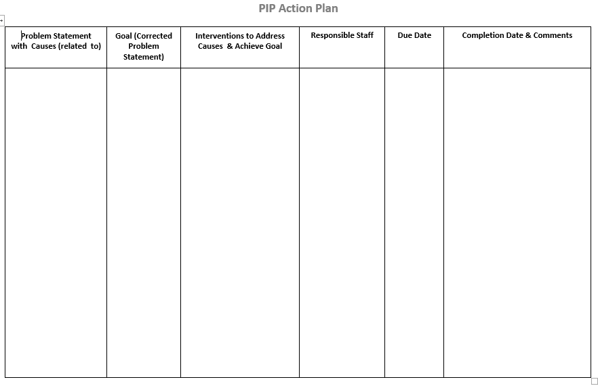

The following form may be utilized in developing and monitoring Action Plans:
Insert facility specific form here
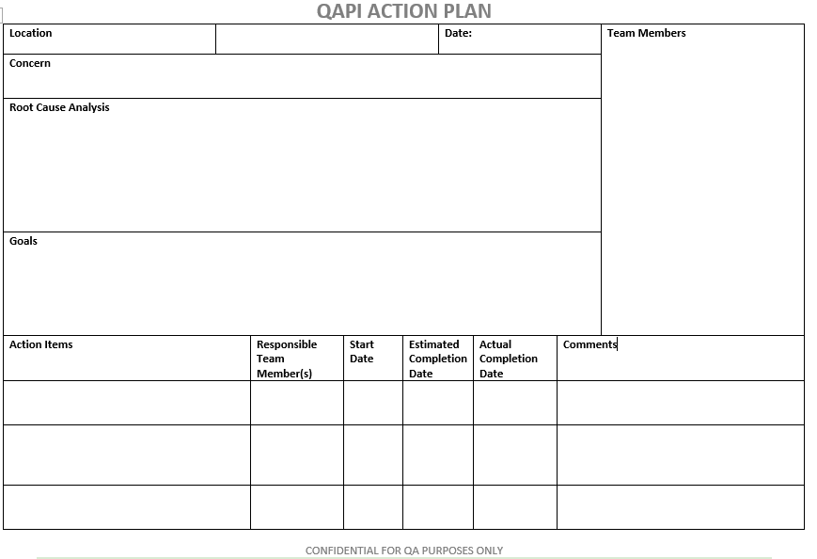

PIP activities will be reported to residents, families and staff at least one time during the PIP. More frequent communication may be required as determined by the QAPI Quality Manager. Communication may occur via posters, bulletin boards, newsletters, and/or meetings with residents, family, staff and board members. To monitor the status of PIPs within our building, we will utilize CMS Performance Improvement Project (PIP) Inventory.
The project lead will also provide verbal and written documentation at the monthly QAPI Committee meetings. Meeting minutes will include information shared.

Systematic Analysis and Systemic Action
Example: ABC Facility uses a systematic approach to determining the root cause of an issue and any contributing factors. Facility staff and management have been trained on Root Cause Analysis. The PIP team identifies the root cause through utilization of many different tools, including:
- Fishbone Diagram
- Five Whys
- Cause and Effect Diagram
- Healthcare Failure Mode and Effect analysis (HFMEA)
The team considers the implications of any interventions or changes to systems for potential negative outcomes in other areas. The team will determine whether a pilot test or facility wide change is appropriate based on the facts gathered.
We utilize Plan-Do-Study-Act (PDSA) as our rapid-cycle improvement strategy with outcomes reported ongoing to the QAPI Quality Manager and quarterly to the QAPI Steering Committee.
Each PIP team determines the timing for conduction of periodic measurements and reviews to evaluate whether new actions/interventions are being followed/performed consistently. If any backsliding has occurred, the team will continue with the PDSA cycle with changes in processes/procedures as required.
Evaluation
The QAPI program will be evaluated annually by the QAPI Steering Committee with input from the Leadership Team/Executive Leadership. This review will include whether goals were met, if standards of practice are being followed, any training needs will be identified and addressed, and staff opinion on the QAPI process will be obtained via survey. Current trends in long term care will be considered along with strategic plans for ABC Facility. Any variances in systems and processes will be identified and included in the coming year’s QAPI plan.

This plan was established on August 14, 2017 and will be revisited and revised as needed annually at a minimum.

Resources
Measure/Indicator Development Worksheet. (2016). Retrieved December 7, 2016, from https://www.cms.gov/Medicare/Provider-Enrollment-and-Certification/QAPI/downloads/MeasIndicatDevWksdebedits.pdf

Measure/Indicator Collection and Monitoring Plan. (2016). Retrieved December 7, 2016, from https://www.cms.gov/Medicare/Provider-Enrollment-and-Certification/QAPI/downloads/MeasIndCollectMtrPlandebedits.pdf
Prioritizing Worksheet for Performance Improvement Projects. (2016). Retrieved December 7, 2016, from https://www.cms.gov/Medicare/Provider-Enrollment-and-Certification/QAPI/downloads/PIPCharterWkshtdebedits.pdf

Worksheet to Create a Performance Improvement Project Charter. (2016). Retrieved December 7, 2016, from https://www.cms.gov/Medicare/Provider-Enrollment-and-Certification/QAPI/downloads/PIPCharterWkshtdebedits.pdf

CMS PIP Inventory. (2016). Retrieved 2017, January 12 from https://www.cms.gov/medicare/provider-enrollment-and-certification/qapi/downloads/pipinventorydebedits.pdf

