COVID-19

Antigen Testing Policy
(05.27.2021)
COVID-19 Antigen Testing

Policy

It is the policy of this facility to test residents and staff for COVID-19, based upon a facility plan that includes parameters and frequency set forth by the Health and Human Services Secretary, State guidance and local public health recommendations in accordance with current standards of practice.

Purpose

The purpose of testing is to enhance efforts to identify cases of COVID-19 quickly to put in place immediate interventions to remove exposure risks for the residents and staff. Uses of antigen testing in nursing homes will be implemented in addition to recommended Infection Prevention and Control measures and includes:
- To test symptomatic residents and staff,
- To test asymptomatic residents and facility staff in facilities as part of the COVID-19 outbreak response,
- To test asymptomatic facility staff without a COVID-19 outbreak as required by CMS recommendations, and
- To test residents and facility staff who were exposed to persons with COVID-19 outside of the nursing home.

Definitions

Antibody Testing: Testing from a blood test that looks for antibodies that develop several days to weeks after infection. This is not a diagnostic test.

Antigen Testing: “Antigen tests are immunoassays that detect the presence of a specific viral antigen, which implies current viral infection. Antigen tests are currently authorized to be performed on nasopharyngeal or nasal swab specimens placed directly into the assay’s extraction buffer or reagent.”¹ “Antigen tests are relatively inexpensive, and most can be used at the point of care. Most of the currently authorized tests return results in approximately 15–30 minutes. Antigen tests for SARS-CoV-2 are generally less sensitive than real-time reverse transcription polymerase chain reaction (RT-PCR) and other nucleic acid amplification tests (NAATs) for detecting the presence of viral nucleic acid.” ¹
Outbreak-COVID-19: “a new COVID-19 infection in any healthcare personnel (HCP) or any nursing home-onset COVID-19 infection in a resident.”² “Residents who were placed into Transmission-Based Precautions on admission and developed SARS-CoV-2 infection within the 14-day period after admission.”³

Point of Care Testing “is diagnostic testing that is performed at or near the site of resident care.”²

Rapid POC Testing Devices “are prescription use tests under the Emergency Use Authorization and must be ordered by a healthcare professional licensed under the applicable state law or a pharmacist under HHS guidance.”²

Screening Testing “Antigen tests have been used for screening testing in high-risk congregate housing settings, such as nursing homes, in which repeat testing has quickly identified people with COVID-19, informing infection prevention and control measures, thus preventing transmission. In this case, and where rapid test turnaround time is critical, there is value in providing immediate results with antigen tests, even though they may have lower sensitivity than NAATs.”¹

(Facility) Staff “includes employees, consultants, contractors, volunteers, and caregivers who provide care and services to residents on behalf of the facility, and students in the facility’s nurse aide training programs or from affiliated academic institutions.”²

Surveillance Testing “Surveillance testing is primarily used to gain information at a population level, rather than an individual level. Surveillance testing may be random sampling of a certain percentage of a specific population to monitor for increasing or decreasing prevalence and determining the population effect from community interventions such as social distancing.”⁴

Procedure

Preparation:

- Facility will determine capacity for testing by trained facility nurses.
  - If additional support is necessary, contact local public health department for collaboration.
- Facility will determine the type of Emergency Use Authorization for FDA approved viral test that will be used for testing residents and staff.
  - If testing is sent to the laboratory, select lab that can process a large number of tests with rapid reporting of results (24-48 hours)
- Facility will determine appropriate specimen source.
- Supplies: Facility will obtain and maintain specimen collection kits and PPE for specimen collection.
  - PPE includes:
    - N95 or higher-level respirator (facemask if respirator is not available)
    - Eye protection
    - Gloves
    - Gown
- The Medical Director will order testing by standing order if permitted by State law.
- Residents and facility staff will be prioritized for testing:
  - Symptomatic individuals will be prioritized first for testing
    - All facility staff and residents with signs and symptoms must be tested
      - Symptomatic facility staff will be immediately sent home pending results. Once results received, follow facility policy on return to work. Consistent with CDC’s “Criteria for Return to Work for healthcare Personnel with SARS-CoV-2 Infection (Interim Guidance).” https://www.cdc.gov/coronavirus/2019-ncov/hcp/return-to-work.html
        - If antigen test is negative on symptomatic employee, perform a confirmatory nucleic acid amplifications tests (NAAT) such as reverse transcriptase polymerase chain reaction (RT-PCR)
      - Symptomatic residents will be placed on transmission-based precautions (with staff using all PPE recommended for the care of a resident with suspected COVID-19 infection) while test results are pending.
        - It is recommended that if both COVID-19 and Influenza Viruses are co-circulating, resident should be tested for both viruses
        - If antigen test is negative, continue with transmission-based precautions and perform a confirmatory nucleic acid amplifications test (NAAT) such as reverse transcriptase polymerase chain reaction (RT-PCR)

Outbreak: ”Any new cases that arise in the facility”²:
    - Test all facility staff and residents that previously tested negative. All facility staff and residents that test negative will be retested every three to seven days until testing identifies no new cases of COVID-19 infection among staff or residents for a period of at least 14 days since the most recent positive result.²
      - Consult with local public health department for questions/concerns
    - Facility staff and residents who test positive for COVID-19 do not need repeat testing.
      - Residents will be placed in transmission-based precautions following CDC guidance on Discontinuation of Transmission-based Precautions and Disposition of Patients with COVID-19 in Healthcare Settings (Interim Guidance): https://www.cdc.gov/coronavirus/2019-ncov/hcp/disposition-hospitalized-patients.html
      - Facility staff will return to work following CDC Guidance, “Criteria for Return to Work for Healthcare Personnel with SARS-CoV-2 Infection (Interim Guidance): https://www.cdc.gov/coronavirus/2019-ncov/hcp/return-to-work.html

  - Routine Testing:
    - Facility Staff: Routine testing of unvaccinated staff is dependent upon the extent of the virus in the community. Fully vaccinated staff do not need to be routinely tested. Guidance represents minimum testing expected and can be adjusted considering other factors (as well as State guidance) that could increase risk:
      - Neighboring county with a higher positivity rate
      - Multiple employees living in a county with a higher positivity rate
      - Rates of emergency room visits
    - Asymptomatic residents will not be routinely tested unless prompted by a change in circumstance
    - Asymptomatic individuals testing antigen positive will have a confirmatory nucleic acid amplifications test (NAAT) such as reverse transcriptase polymerase chain reaction (RT-PCR)
      - Employee will be excluded from work pending NAAT results
      - Resident will be placed on transmission-based precautions (not on a COVID-19 unit) pending results in a single room
    - Facility may consider routine testing for residents who leave the facility frequently (i.e. dialysis, chemotherapy)
    - The Infection Preventionist or designee, will use the county positivity rate (https://data.cms.gov/stories/s/COVID-19-Nursing-Home-Data/bkwz-xpvg ) in the prior week to trigger facility staff testing frequency according to table 2 below²:
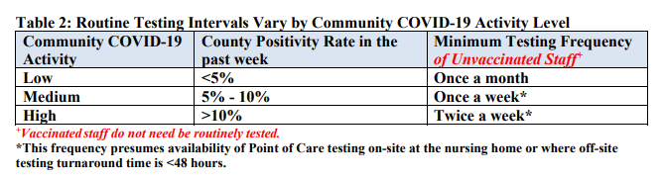

    - If the facility is unable to meet the 48-hour turn-around time due to testing supply shortages, limited access, or inability of the laboratory to process the tests withing 48-hours, the facility will:
      - Document all efforts to obtain quick turn-around test results
      - Contact with local/state health departments
      - Document all attempts to obtain testing supplies

- The facility will make all attempts to provide testing that will obtain onsite rapid testing results, preferably within 24 hours.

- Testing Refusals:
  - Facility Staff:
    - Facility employees with signs or symptoms of COVID-19 and who refuse testing will be prohibited from entering the facility until return to work criteria are met.
    - Facility employees without COVID-19 signs or symptoms who refuse routine testing (identify facility action consistent with facility occupational health policies and local jurisdiction policies)
    - “If outbreak testing has been triggered and a staff member refuses testing, the staff member should be restricted from the building until the procedures for outbreak testing have been completed.”¹
  - Residents: Residents or the resident representative may refuse COVID-19 testing. Education will be provided to the resident/representative on the importance of testing for COVID-19, how test is performed and interventions that may need to be implemented due to refusal. An alternate specimen collection source may be discussed (i.e. anterior nares).
    - Residents with signs or symptoms of COVID-19 who refuse testing will be placed on isolation with transmission-based precautions until criteria for discontinuing transmission-based precautions are met.
    - During an outbreak if asymptomatic resident refuses testing:
      - Vigilant evaluation each shift for signs and symptoms of COVID-19 will be completed and documented
      - Resident will be instructed and observed to maintain appropriate distance from other residents
      - Resident will be instructed and monitored for use of a face covering
      - Resident will be instructed and monitored for appropriate hand hygiene practices

- Priority of testing will be based upon CMS QSO-20-38-NH²:

“Table 1 Testing Summary
Testing Trigger | Staff | Residents
Symptomatic individual identified | Staff, vaccinated and unvaccinated, with signs and symptoms must be tested | Residents, vaccinated and unvaccinated, with signs and symptoms must be tested
Outbreak (Any new case arises in facility) | Test all staff, vaccinated and unvaccinated, that previously tested negative until no new cases are identified* | Test all residents, vaccinated and unvaccinated, that previously tested negative until no new cases are identified*
Routine Testing | According to Table 2 above | Not recommended, unless the resident leaves the facility routinely
*For outbreak testing, all staff and residents should be tested, and all staff and residents that tested negative should be retested every 3 days to 7 days until testing identifies no new cases of COVID-19 infection among staff or residents for a period of at least 14 days since the most recent positive result. For more information, please review the section below titled, “Testing of Staff and Residents in Response to an Outbreak.”²

- Documentation
  - Documentation should include:
- Logs of county level positivity rate
- Testing schedules
- List of vaccinated residents and employees
- Employee testing records
- Resident testing records
- For symptomatic residents and employees:
  - Date
  - Time
  - Signs and or Symptoms
  - When testing was conducted
  - When results obtained
  - Actions taken related to test result
- Identification of a new COVID-19 Case (Outbreak)
  - Date the case was identified
  - Date all residents tested
  - Date all staff tested
  - Dates all residents retested
  - Dates all staff retested
  - Documentation of no new cases of COVID-19 among staff or residents for period of at least 14 days since most recent positive result
- Staff routine testing documentation
  - County positivity rate
  - Corresponding testing frequency identified
  - Date each positivity rate collected
  - Dates and results for all employee testing
- Shortage of testing supplies
  - For shortage of testing supplies, document:
    - Shortage
    - Attempts to order supplies
    - When the facility contacted state and local health department to assist in testing
      - Obtaining testing supplies
      - Processing test results

- Additional Testing Considerations
  - Staff and residents who have recovered from COVID-19 and have no symptoms (asymptomatic) will not be retested for COVID-19 within 3 months following symptom onset.
    - Residents or staff who show symptoms within 3 months following symptom onset of initial infection will be managed according to physician/public health recommendations.
  - Staff and residents will be tested if symptomatic or with a COVID-19 outbreak 3 months after the date of symptom onset of prior infection or confirmed positive COVID-19 test.
    - Review and consult with infectious diseases specialist and local public health for residents who are determined to be potentially infectious and continue transmission-based precautions.
  - Contact State (or Local) Public Health Department for resident or staff who test positive for contact tracing
  - Facilities may test visitors if adequate testing supplies are available
    - Testing supplies will be prioritized for residents and staff prior to testing visitors

- Facilities that conduct tests with own staff and equipment, including any point-or-care devices provided by the Department of Health and Human Services (HHS) must have a CLIA Certificate of Waiver.
  - “CLIA regulations have been updated to require all laboratories to report SARS-CoV-2 test results in a standardized format and at a frequency specified by the Secretary.”⁸ HHS has determined that nursing homes must report point-of-care testing through the National Healthcare Safety Network (NHSN).

- The nurse will perform hand hygiene, don full PPE, and collect specimens as soon as possible when testing is decided. Specimens will include:
  - An anterior-nares (nasal swab) or deep nasal swab is preferred for point-of-care antigen testing
  - A nasopharyngeal specimen (NP)
  - An oropharyngeal specimen (OP)

- The nurse will only use tests and test components that have not exceeded the expiration date or show any signs of compromise to the integrity of the components

- The nurse will change gloves in between the collection of the specimen and after adding the specimen to the testing device

- The nurse will follow manufacturer’s directions for testing in the exact order indicated (add manufacturer’s POC testing directions here)

- The nurse will follow manufacturer’s directions for cleaning and disinfection (add manufacturer’s POC cleaning and disinfection directions here)

- No test devices, reagent tubs, solutions or swabs will be reused.

- Waste from testing will be handled as all other biohazardous waste.

- Doff PPE according to PPE procedure and perform hand hygiene.

- The nurse will document:
  - Testing results
    - Date
    - Time
    - Resident or Staff
    - Symptoms
    - Actions Taken
    - Reporting

Algorithm for Interpreting Antigen Test Results⁷

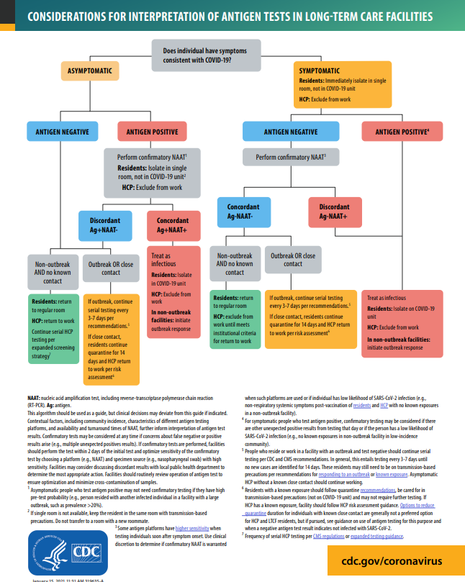

References and Resources

¹Centers for Disease Control and Prevention. Interim Guidance for Antigen Testing for SARS-CoV-2. Updated May. 13, 2021: https://www.cdc.gov/coronavirus/2019-ncov/lab/resources/antigen-tests-guidelines.html

²Centers for Medicare & Medicaid Services: QSO-20-38-NH, Interim Final Rule (IFC), CMS-3401-IFC, Additional Policy and Regulatory Revisions in Response to the COVID-19 Public Health Emergency related to Long-Term Care (LTC) Facility Testing Requirements and Revised COVID19 Focused Survey Tool. Revised 04/27/2021: https://www.cms.gov/files/document/qso-20-38-nh.pdf

³Centers for Disease Control and Prevention. SARS-CoV-2 Antigen Testing in Long Term Care Facilities. Considerations for Use of SARS-CoV-2 Antigen Testing in Nursing Homes. Updated Jan. 7, 2021: https://www.cdc.gov/coronavirus/2019-ncov/hcp/nursing-homes-antigen-testing.html

⁴United States Food & Drug Administration. COVID-19 Test Uses: FAQs on Testing for SARS-CoV-2: https://www.fda.gov/medical-devices/coronavirus-covid-19-and-medical-devices/covid-19-test-uses-faqs-testing-sars-cov-2

⁵Centers for Disease Control and Prevention. Clinical Questions about COVID-19: Questions and Answers. Updated Mar. 4, 2021: https://www.cdc.gov/coronavirus/2019-ncov/hcp/faq.html#Testing-in-Nursing-Homes

⁶ United States Food & Drug Administration. FAQs on Testing for SARS-CoV-2: https://www.fda.gov/medical-devices/coronavirus-covid-19-and-medical-devices/faqs-testing-sars-cov-2#general-screening-asymptomatic

⁷Centers for Disease Control and Prevention. Considerations for Interpreting Antigen Test Results in Nursing Homes. January 15, 2020: https://www.cdc.gov/coronavirus/2019-ncov/downloads/hcp/nursing-home-testing-algorithm-508.pdf

⁸Centers for Medicare & Medicaid Services: QSO-20-37-CLIA, NH, Interim Final Rule (IFC), CMS-3401-IFC, Updating Requirements for Reporting of SARS-CoV-2 Test Results by Clinical Laboratory Improvement Amendments of 1988 (CLIA) Laboratories, and Additional Policy and Regulatory Revisions in Response to the COVID-19 Public Health Emergency. August 26, 2020: https://www.cms.gov/files/document/qso-20-37-clianh.pdf

Centers for Disease Control and Prevention. Interim Guidelines for Collecting, Handling, and Testing Clinical Specimens for COVID-19. Updated Feb/ 26, 2021: https://www.cdc.gov/coronavirus/2019-ncov/lab/guidelines-clinical-specimens.html

Centers for Disease Control and Prevention. Interim Guidelines for COVID-19 Antibody Testing. Updated Mar. 17, 2021: https://www.cdc.gov/coronavirus/2019-ncov/lab/resources/antibody-tests-guidelines.html

Centers for Disease Control and Prevention. Testing and Management Considerations for Nursing Home Residents with Acute Respiratory Illness Symptoms when SARS-CoV-2 and Influenza Viruses are Co-circulating, November 23: https://www.cdc.gov/flu/professionals/diagnosis/testing-management-considerations-nursinghomes.htm

Centers for Disease Control and Prevention. Interim Infection Prevention and Control Recommendations to Prevent SARS-CoV-2 Spread in Nursing Homes. Updated, Mar. 29, 2021: https://www.cdc.gov/coronavirus/2019-ncov/hcp/long-term-care.html

Centers for Disease Control and Prevention. Testing Guidelines for Nursing Homes. Interim SARS-CoV-2 Testing Guidelines for Nursing Home Residents and Healthcare Personnel. Updated January 7, 2021 https://www.cdc.gov/coronavirus/2019-ncov/hcp/nursing-homes-testing.html

Centers for Disease Control and Prevention. COVID-19 Testing Overview. Updated Mar. 17, 2021: https://www.cdc.gov/coronavirus/2019-ncov/symptoms-testing/testing.html

Centers for Disease Control and Prevention. Guidance for SARS-CoV-2 Point-of-Care and Rapid Testing. Updated Mar. 12, 2021: https://www.cdc.gov/coronavirus/2019-ncov/lab/point-of-care-testing.html

United States Food & Drug Administration. Coronavirus Testing Basics. https://www.fda.gov/consumers/consumer-updates/coronavirus-testing-basics

United States Health & Human Services. COVID-19 Pandemic Response, Laboratory Data Reporting: Cares Act Section 18115: https://www.hhs.gov/sites/default/files/covid-19-laboratory-data-reporting-guidance.pdf

This Page Intentionally Left Blank

