COVID-19 Testing

Billing for COVID-19 Tests
(05.28.2021)

Billing for COVID-19 Testing

Medicare

Medicare is usually the primary payer for Medicare covered testing.

Medicare covers the following diagnostic viral testing for nursing home residents consistent with “CDC Testing Guidelines for Nursing Homes”:

- Testing residents with signs or symptoms of COVID-19
- Testing asymptomatic residents with known or suspected exposure to an individual infected with SARS-CoV-2 including close and expanded contacts (e.g., there is an outbreak in the facility)
- Initial (baseline) testing of asymptomatic residents without known or suspected exposure to an individual infected with SARS-CoV-2 as part of the recommended reopening process
- Testing to determine resolution of infection

Medicare will make payment for one diagnostic test per resident without an order from a physician, practitioner, pharmacist, or other authorized health care professional. All subsequent tests require such an order.

Medicare does not cover non-diagnostic surveillance testing.

If Medicare is a secondary payer, the facility will need to check with the primary payer for billing guidance.

See the algorithm¹ “Medicare Payment for COVID-19 Viral Testing: Skilled Nursing Facility/Nursing Facility” below for further guidance.

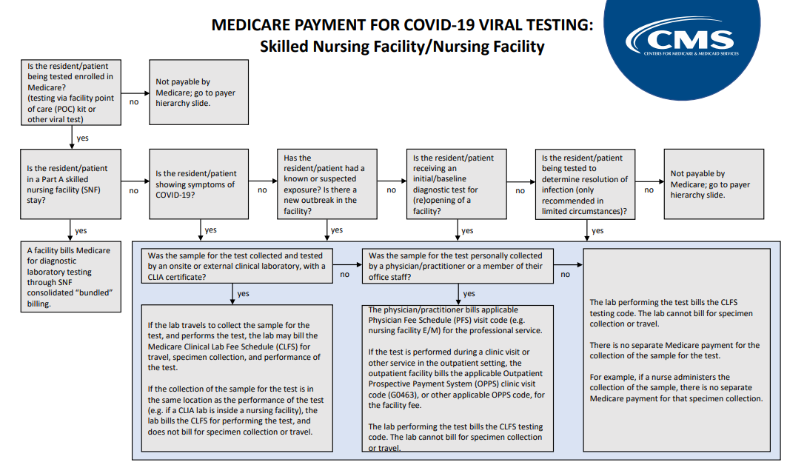

https://edit.cms.gov/files/document/covid-medicare-payment-covid-19-viral-testing-flow-chart.pdf
Medicaid

Medicaid may cover testing; however, facilities should direct questions regarding billing to the state-specific Medicaid agency and/or contracted Medicaid managed care plan for information on testing coverage, payment, and coding for Medicaid beneficiaries. Medicaid pays after most other payers.

New Optional Medicaid Eligibility Group for Uninsured Individuals

The Families First Coronavirus Response Act (FFCRA) and Coronavirus Aid, Relief, and Economic Security (CARES) Act added a new optional Medicaid eligibility group for uninsured individuals, effective March 18, 2020. Individuals eligible for this group receive a limited benefit package of services related to testing and diagnosis of COVID-19 during the public health emergency.

Additional information on eligibility, covered benefits, and federal medical assistance percentage (FMAP) for the new COVID-19 testing group is available here: https://www.medicaid.gov/state-resource-center/downloads/covid-19-section-6008-CARES-faqs.pdf and here: https://www.medicaid.gov/state-resource-center/downloads/covid-19-faqs.pdf

Uninsured

The Health Resources and Services Administration (HRSA) COVID-19 Claims Reimbursement to Health Care Providers and Facilities Testing and Treatment of the Uninsured Program “provides reimbursement directly to eligible providers for COVID-19 testing and treatment services furnished to uninsured individuals. Reimbursement is generally made at the Medicare payment rate.

“To access these funds, providers must enroll in the program as a provider participant, sign the terms and conditions of the program, check patient eligibility, and submit patient information. Once they have done so, they can submit claims for direct reimbursement for COVID-19 testing and treatment services furnished to uninsured individuals on or after February 4, 2020.

“Providers must verify and attest that to the best of the provider’s knowledge at the time of claim submission, the patient was uninsured at the time the services were provided. If the provider subsequently receives reimbursement for any items from other coverage, the provider must return the payment that duplicates other reimbursement to HRSA.

“Additional information is available here: https://www.hrsa.gov/coviduninsuredclaim/frequently-asked-questions “¹

Private Insurance

“Section 6001 of the Families First Coronavirus Response Act (FFCRA) generally requires group health plans and health insurance issuers to provide benefits for certain items and services related to testing for the detection or the diagnosis of COVID-19 when those items or services are furnished on or after March 18, 2020, and during the public health emergency.

“Under FFCRA, plans and issuers must provide this coverage without imposing any cost-sharing requirements (including deductibles, copayments, and coinsurance), prior authorization, or other medical management requirements.

“Section 3201 of the Coronavirus Aid, Relief, and Economic Security (CARES) Act amended section 6001 of the FFCRA to include a broader range of diagnostic tests that plans and issuers must cover without any cost-sharing requirements, prior authorization, or other medical management requirements.

“Section 3202(a) of the CARES Act generally requires plans and issuers providing coverage for these items and services to reimburse any provider of COVID-19 diagnostic testing an amount that equals the negotiated rate or, if the plan or issuer does not have a negotiated rate with the provider, the cash price for such service that is listed by the provider on a public website. (The plan or issuer may negotiate a rate with the provider that is lower than the cash price.)

“Additionally, during the public health emergency, section 3202(b) of the CARES Act requires providers of diagnostic tests for COVID-19 to make public the cash price of a COVID-19 diagnostic test on the provider’s public internet website or face potential enforcement action including civil monetary penalties.

“Health insurance issuers and group health plans must cover COVID-19 diagnostic testing as determined medically appropriate by the individual’s health care provider, consulting CDC guidelines as appropriate.

“Health insurance issuers and group health plans are not required to cover non-diagnostic tests (i.e., testing done for public health surveillance purposes) without cost-sharing.

“Additional information is available here, including information on which tests are required to be covered: https://www.cms.gov/files/document/FFCRA-Part-43-FAQs.pdf ”²

Additional Funding Sources

The CDC awarded funds and provided guidance to state and local jurisdictions to help them access CDC Preparedness and Response Supplemental Funding as well as CARES Act funding in support of COVID-19 Response. “This funding may be used for a variety of activities including:

- Enhancing testing capacity.
- Establishing or enhancing the ability to aggressively identify cases, conduct contact tracing and follow up, as well as implement appropriate containment measures.
- Controlling COVID-19 in high-risk settings and protect vulnerable or high-risk populations.
- Improving morbidity and mortality surveillance.
- Working with healthcare systems to manage and monitor system capacity.”³

Facilities should contact state and local public health agencies for further information on how their state is using these funds.

The Department of Health and Human Services (HHS) through its Provider Relief Fund makes payments to facilities and providers to provide financial relief in response to the COVID-19 pandemic. These funds must be used for increased healthcare related expenses or lost revenue attributable to coronavirus and covers a broad range of unreimbursed expenses.

Additional information on eligibility, payment formulas, and distribution timelines is available at: https://www.hhs.gov/coronavirus/cares-act-provider-relief-fund/index.html

References

^{1,2,3} Medicare Payment for COVID-19 Viral Testing: Skilled Nursing Facility/Nursing Facility https://edit.cms.gov/files/document/covid-medicare-payment-covid-19-viral-testing-flow-chart.pdf

Resources

Centers for Disease Control and Prevention. Testing Guidelines for Nursing Homes, Updated Jan. 7, 2021: https://www.cdc.gov/coronavirus/2019-ncov/hcp/nursing-homes-testing.html

Centers for Medicare & Medicaid Services. CMS SARS-CoV-2 Laboratory Testing Comparison, May 21, 2020. QSO 20-06-CLIA: https://www.cms.gov/files/document/admin-info-20-06-clia.pdf

