Emergency Preparedness:
Communication Plan

State logo added here. If not, delete text box

Emergency Preparedness Toolkit
Communication Plan

Facilities should develop and maintain an emergency preparedness communication plan that aligns with local, state and federal requirements. The communication plan should include processes related to how the facility coordinates resident care within the facility and externally, how the facility interacts and coordinates with emergency management services, how the facility communicates resident and staff information while protecting privacy, communication of the facility’s response to the emergency, how the facility coordinates with officials and across health care providers.

In accordance to Appendix Z of the State Operations Manual (SOM), the Communication Plan associated with Emergency Preparedness should incorporate the following:
- Develop an emergency preparedness communication plan that complies with federal, state, and local laws
- Include:
  - Contact information – for relevant partners
  - Methods to communicate essential information with relevant partners
  - Methods to share protected patient information
  - Primary and alternate means of communication
Contact information
The communication plan should include:
Contact information (name and contact) for internal needs:
- Residents
- Staff
- Resident physicians
- Volunteers
- Service and resource entities under arrangement
- Over health care providers

External Resources
- Local, state, regional and federal emergency preparedness staff
- State Department of Health and Human Services
- Ombudsman
- Local authorities
- Transfer entities
- Transportation entities
- Vendors and service providers

Information should be current, accessible and readily available.
Methods to communicate essential information with relevant partners
The facility communication plan needs to include primary and alternative means for communicating. Included in the plan should be contact information related to local, state, regional and federal emergency authorities as well as contact information and corresponding agreements with other partners (providers, agency staffing organizations, vendors) who are part of the facility’s emergency preparedness plan. Additionally, the facility should ensure that the secondary or alternate methods of communication is compatible with the communication systems of those on their contact list.

Methods to share protected patient information
The facility communication plan should include methods for medical and financial information sharing requirements. The facility should include in the plan the primary and alternative methods, in case of loss or failure, in which resident medical information and records are shared with agreed upon entities. These processes need to be in alignment with HIPAA and HITECH requirements. Review of the facility HIPAA compliant policies and procedures should include interventions of sharing information in case of an emergency as well as evacuation. The facility policies should be reviewed and revised to include the required transfer notice and documentation processes per the requirements of participation. See the HIPAA Decision Flow process, per CMS, at the end of this chapter.

Facility communication plan should include a process for providing facility specific information, which is readily accessible for emergency management authorities, including:
- Occupancy/Census
- Resident population demographics
- Specialty programs and special needs of residents including specialty equipment if applicable
- Assistance with evacuation needs
- Supply and pharmaceutical contingency
- Transportation needs
- Other
It is recommended that the facility share the overview of the emergency plan with residents, resident representatives and stakeholders so that they are informed of the plan and emergency processes. The facility may develop a fact sheet outlining key components of the plan and the roles/responsibilities of staff as well as communication processes including how to contact the facility during an emergency.

Primary and alternate means of communication
The facility communication plan needs to include primary and alternative means for communicating. Additionally, the facility should ensure that the secondary or alternate methods of communication is compatible with the communication systems of those on their contact list.

Additional Information and Resources
When an emergency occurs, the need to respond is immediate. That is “Job 1.” The need to communicate would be “Job 1a.” If operations are disrupted, internal and external customers will want to know how they will be impacted. Regulators may need to be notified and local government officials will want to know what is going on in their community. Employees and their families will be concerned and want information. Neighbors living near the facility may need information –especially if they are threatened by the incident. All of these “audiences” will want information before the facility has a chance to begin communicating.

An important component of the Emergency Preparedness program is the crisis communications plan. A facility must be able to respond promptly, accurately, and confidently during an emergency in the hours and days that follow. Many different audiences must be reached with information specific to their interests and needs. The image of the facility can be positively or negatively impacted by public perceptions of the handling of the incident. Understanding potential audiences is key, as each audience wants to know: “How does it affect me?” Guidance for scripting messages that are specific to the interests of the audience is another element of the communication plan.

Audiences
Understanding the audiences that a facility needs to reach during an emergency is one of the first steps in the development of a crisis communications plan. There are many potential audiences that will want information during and following an incident and each has its own needs for information. The challenge is to identify potential audiences, determine their need for information and then identify who within the facility is best able to communicate with that audience.
Potential audiences include:
- Residents
- Family members of residents
- Employees
- Family members of employees
- Responders and Emergency Management
- News media
- Community – especially neighbors living near the facility
- Company management, directors, and investors
- Government officials, regulators, and other authorities
- Suppliers
Contact Information
Contact information for each audience should be compiled and immediately accessible during an incident. Existing information such as resident representative, supplier, and employee contact information may be exportable from existing databases. Include as much information for each contact as possible (e.g., organization name, contact name, business telephone number, cell number, fax number, and email address).

Lists should be updated regularly, secured to protect confidential information and available to authorized users at the emergency operations center or an alternate location for use by members of the crisis communications team. Electronic lists can also be hosted on a secure server for remote access with a web browser. Hard copies of lists should also be available at the alternate location.

Residents and Their Family Members
Customers are the life of a business, so customer contact is a top priority. Customers may become aware of a problem as soon as their phone calls are not answered or their electronic communications are not acknowledged. The business continuity plan should include action to redirect incoming telephone calls to a second call center (if available) or to a voice message indicating that the business is experiencing a temporary problem.

Suppliers
The crisis communication or business continuity plan should include documented procedures for notification of suppliers. The procedures should identify when, how, and by whom they should be notified.

Management
Protocols for when to notify management should be clearly understood and documented. Consider events that occur on a holiday weekend or in the middle of the night. It should be clear to staff what situations require immediate notification of management regardless of the time of day. Similar protocols and procedures should be established for notification of directors, investors, and other like stakeholders. Management does not want to learn about a problem from the new media.

Government Official and Regulators
Communications with government officials depends upon the nature and severity of the incident and regulatory requirements. Facilities that fail to notify a regulator within the prescribed time risk incurring a fine. Occupational Safety and Health Administration (OSHA) regulations require notification to OSHA when there are three or more hospitalizations from an accident or if there is a fatality. Environmental regulations require notification if there is chemical spill or release that exceeds threshold quantities. Other regulators may need to be notified if there is an incident involving product tampering, contamination, or quality. Notification requirements specified in regulations should be documented in the crisis communication plan.

Employees, Victims, and Their Families
Human Resources (HR) is responsible for the day-to-day communications with employees regarding employment issues and benefits administration. HR management should assume a similar role on the crisis communications team. HR should coordinate communications with management, supervisors, employees, and employee families. HR should also coordinate communications with those involved with the care of employees and the provision of benefits to employees and their families. Close coordination between management, company spokesperson, public agencies, and HR is needed when managing the sensitive nature of communications related to an incident involving death or serious injury.

The Community
If there are hazards at a facility that could impact the surrounding community, then the community becomes an important audience. If so, community outreach should be part of the crisis communications plan. The plan should include coordination with public safety officials to develop protocols and procedures for advising the public of any hazards and the most appropriate protective action that should be taken if warned.

News Media
If the incident is serious, then the news media will be on scene or calling to obtain details. There may be numerous requests for information from local, regional, or national media. The challenge of managing large numbers of requests for information, interviews, and public statements can be overwhelming. Prioritization of requests for information and development of press releases and talking points can assist with the need to communicate quickly and effectively.

Develop a company policy that only authorized spokespersons are permitted to speak to the news media. Communicate the policy to all employees explaining that it is best to speak with one informed voice.
Determine in advance who will speak to the news media and prepare that spokesperson with talking points, so they can speak clearly and effectively in terms that can be easily understood.

Messages
During and following an incident, each audience will seek information that is specific to them. “How does the incident affect my family member, job, safety, community …?” These questions need to be answered when communicating with each audience.
After identifying the audiences and the spokesperson assigned to communicate with each audience, the next step is to script messages. Writing messages during an incident can be challenging due to the pressure caused by “too much to do” and “too little time.” Therefore, it is best to script message templates in advance if possible.
Pre-scripted messages should be prepared using information developed during the risk assessment. The risk assessment process should identify scenarios that would require communications with stakeholders. There may be many different scenarios but the need for communications will relate more to the impacts or potential impacts of an incident:
- Accidents that injure employees or others
- Property damage to facilities
- Liability associated injury to or damage sustained by others
- Service interruptions
- Chemical spills or releases with potential off-site consequences, including environmental
- Care quality issues
Messages should be scripted to address the specific needs of each audience, which may include:
- Resident/Resident Representative - “Is it safe?”
- Employee – “When should I report to work?” “Will I have a job?” “Will I get paid during the shutdown or can I collect unemployment?” “Will overtime be mandated?” “What happened to my co-worker?” “What are you going to do to address my safety? My family’s safety?” “Is it safe to go back to work?”
- Government Regulator – “When did it happen?” What happened (details about the incident)?” “What are the impacts (injuries, deaths, environmental contamination, safety of residents, etc.)?”
- Elected Official – “What is the impact on the community (hazards and economy)?” “How many employees will be affected?” “When will you be back up and running?”
- Suppliers – “When should we resume deliveries and where should we ship them?” “How many and how soon do you need emergencies supplies?”
- Management – “What happened?” “When did it happen?” “Was anyone injured?” “How bad is the property damage?” “How long do you think service will be down?”
- Neighbors in the Community – “How can I be sure it’s safe to go outside?” “What are you going to do to prevent this from happening again?” “How do I get paid for the loss I incurred?”
- News Media - “What happened?” “Who was injured?” “What is the estimated loss?” “What caused the incident?” “What are you going to do to prevent it from happening again?” “Who is responsible?”
Messages can be pre-scripted as templates with blanks to be filled in when needed. Pre-scripted messages can be developed, approved by the management team and stored on a remotely accessible server for quick editing and release when needed.

Another important element of the crisis communications plan is the need to coordinate the release of information. When there is an emergency or a major impact on the facility, there may be limited information about the incident or its potential impacts. The “story” may change many times as new information becomes available.
One of the aims of the crisis communication plan is to ensure consistency of message. If you tell one audience one story and another audience a different story, it will raise questions of competency and credibility. Protocols need to be established to ensure that the core of each message is consistent while addressing the specific questions from each audience.

Contact and Information Centers
Communications before, during, and following an emergency is bi-directional. Stakeholders or audiences will ask questions and request information. The facility will answer questions and will provide information. This flow of information should be managed through a communication hub.
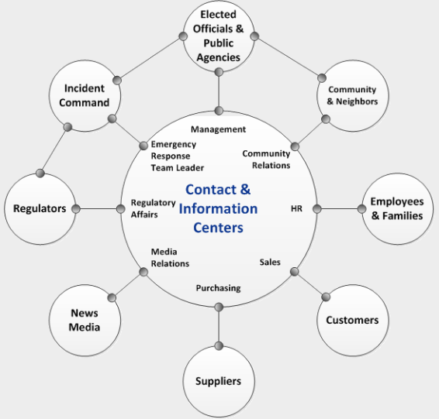

Contact and Information Centers form the “hub” of the crisis communications plan. The centers receive requests for information from each audience and disseminate information to each audience. Employees from multiple departments may be assigned to communicate with a specific audience.
The “contact center” fields inquiries from everyone; therefore, it should be properly equipped and staffed by personnel to answer requests for information. The staff working within the contact center should be provided with scripts and a “frequently asked questions” (FAQ) document to answer questions consistently and accurately.

The “information center” consists of existing staff and technologies (e.g., website, call center, bulletin boards, etc.) that field requests for information during normal business hours. The information center and its technologies can be used to push information out to audiences and post information for online reading.

The crisis communications team, consisting of members of the management team, should operate in an office environment to support the contact and information centers. The offices may be clustered near the emergency operations center or at an alternate site if the primary site cannot be occupied. The goal of the crisis communications team is to gather information about the incident. This should include monitoring the types of questions posed to call center operators or staff in the office; emails received by customer service; social media chatter or stories broadcast by the news media.

Using this input, the crisis communications team can inform management about the issues that are being raised by stakeholders. In turn, management should provide input into the messages generated by the crisis communications team. The team can then create appropriate messages and disseminate information approved for release.

Resources for Crisis Communications
Resources should be available within the primary business site and provisions should be made to set up similar capabilities within an alternate site in case the primary site cannot be occupied.
- Telephones with dedicated or addressable lines for incoming calls and separate lines for outgoing calls
- Access to any electronic notification system used to inform residents and/or employees
- Electronic mail
- Fax machine (preferably one for sending and one for receiving)
- Webmaster access to company website to post updates
- Access to social media accounts
- Access to local area network, secure remote server, message template library and printers
- Hard copies of emergency response, business continuity, and crisis communications plan
- Site and building diagrams, information related to business processes and loss prevention programs (e.g., safety and health, property loss prevention, physical and information/cyber security, fleet safety, environmental management, and care quality)
- Copiers
- Forms for documenting events as they unfold
- Message boards (flipcharts, white boards, etc.
- Pens, pencils, paper, clipboards, and other stationery supplies
HIPAA in Emergency Situations: Preparedness, Planning, and Response

The Privacy Rule protects individually identifiable health information from uses and disclosures that unnecessarily compromise the privacy of an individual. The Rule is carefully designed to protect the privacy of health information, while allowing important health care communications to occur.
The process chart on the following page addresses the release of protected health information for planning or response activities in emergency situations. Additional information can be obtained at https://www.hhs.gov/hipaa/for-professionals/special-topics/emergency-preparedness/decision-tool-overview/index.html.

Additional information addresses the following:
- Who is the source of the information to be disclosed?
  - A covered entity
  - The individual consumer
  - Other agency or organization that is not a covered entity
- To whom is the information being disclosed?
  - Public Health Authority
  - A health care provider for treatment
  - Other agency for public health purposes
  - Other person(s)/agency
- Has the individual consumer signed an authorization permitting disclose?
  - Yes
  - No

Waivers
If the President declares an emergency or disaster and the Secretary of HHS declares a public health emergency, the Secretary may waive sanctions and penalties against a covered hospital that does not comply with certain provisions of the Privacy Rule. The Privacy Rule remains in effect. The waivers are limited and apply only for limited periods of time.

Additional information regarding waivers can be obtained at https://www.hhs.gov/hipaa/for-professionals/faq/1068/is-hipaa-suspended-during-a-national-or-public-health-emergency/index.html.
CMS Resource: https://www.cms.gov/Medicare/Provider-Enrollment-and-Certification/SurveyCertEmergPrep/Downloads/OCR-Emergency-Prep-HIPPA-Disclose.pdf
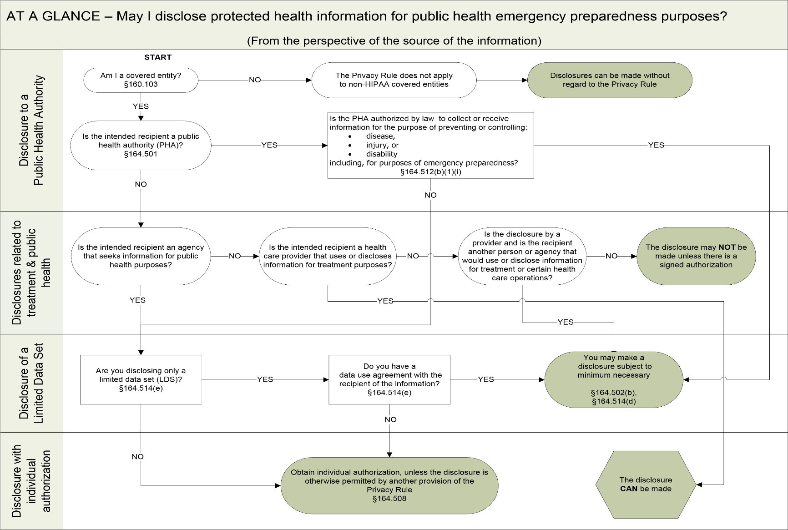
Incident Command Roster Form Emergency Preparedness Plan

ICS Position | Title of Facility Position
Facility Incident Commander
Communications/Information Office
Liaison Officer
Safety & Security Officer
Logistics Lead
Supplies and Resources Lead
Medical/Clinical Lead
Staff/Employee Lead
Continuity of Operations Lead
Finance Lead

Collaboration and Coordination of Partners – Information Grid

Type | Organization Name | Contact information | MOU, Agreement, Contract effective date

Primary and Alternate Communication System Grid

Communications System
Type | Location | Vendor or Supporting Service | Back Up Redundant Service | Staff Responsible
Business Switchboard
Business Cell Phone
2 way Radio
Pagers
Weather Radio
IP Phone
Internet Access

Primary and Alternate Communication Process for Key Contacts

Primary and Alternate Communication Process for Key Contacts
Contact | Primary Method | Secondary Method
Residents
Resident Representatives
Physicians
Medical Director
Key Management Team
Staff
Local EMS
Public Health
State EMS
State Public Health
State DHSS
Federal – CMS
FEMA
ASPR
Critical Phone Numbers

Name/Title | Primary Telephone | Secondary Telephone

SAMPLE Facility Profile

Facility Name
Facility Address
Facility Location (Cross streets, Landmarks, Longitude and Latitude Coordinates)
Facility Telephone #
Facility Fax #
Facility Email
Facility Web Address
Administrator/Phone #
Emergency Contact Person/Phone #
Maintenance Coordinator/Phone #
Insurance Agent/Phone #
Owner/Phone #
Attorney/Phone #
Year Facility Built
Fire Alarm System/Contact #
Security Alarm System/Contact #
# of Licensed Beds/Average Census
Average # of Staff – Days
Average # of Staff - Evenings
Average # of Staff – Nights
Emergency Power Generator
Type Emergency Power Generator Fuel
Emergency Communication System
Like‐Facility #1 for Resident Evacuation*(within 10 miles)/Phone #
Like‐Facility #2 for Resident Evacuation (within 10 miles)/Phone #
Like‐Facility for Resident Evacuation (beyond 25 miles)/Phone #
Like‐Facility for Resident Evacuation (beyond 25 miles)/Phone #
Other
*Our facility has a Memorandum of Understanding (MOU) with at least one nearby facility (within 10 miles) and one out‐of‐the‐immediate‐area facility (beyond 25 miles) to accept evacuated residents, if able to do so.

SAMPLE Emergency Contacts

Type | Telephone #/Email | Contact Name  (if known)
Police
Fire
State Nursing Facility Licensing Agency
Emergency Medical System
Local Emergency Management Agency
Local Medical and Health Coordinator
Ambulance Company #1
Ambulance Company #2
Other Transportation
Power Company
Telephone Company
Water System
Sewer System
Fire Alarm System
Fire Protection – Sprinkler System
Security Alarm System
Emergency Water Supply
Additional Staff
Other

Staff Emergency Contact Roster

Facility Staff Emergency Contact
Name | Department | Contact # | Email | Staff Role in Emergency | Contacted Staff Family?
Resident Physician Contact Roster

Resident Physician Contact
Resident Name | Physician | Contact Date | Documented

Volunteer Emergency Contact Roster

Volunteer Emergency Contact
Name | Department | Contact # | Email | Staff Role in Emergency | Contacted Volunteer Family?

