Incident Command System
In Health Care
Emergency Preparedness Toolkit
Overview
Incident Command System in Health Care

During an emergency, having a structure for authority and decision making is paramount to reducing risk and responding as efficiently and effectively as possible. Designing an Incident Command System (ICS) (also referred as an emergency operations center, incident command center or incident command post) into your emergency preparedness plan is a management system designed to enable effective and efficient domestic incident management by integrating a combination of facilities, equipment, personnel, procedures, and communications operating within a common organizational structure. (FEMA, 2016). This structure provides guidance for how to organize resources and response to an incident and process to manage the response through its successive stages.

Nursing homes should be prepared for any type of incident, emergency or disaster whether it affects only one facility, multiple facilities, regional or national emergencies. While it is important to have an up-to-date plan, facilities should incorporate an Incident Command System (ICS) which will provide an operational, practical and proven approach to disaster management, which is an integral part of the National Incident Management System (NIMS).

Overview - Incident Command System in HealthCare

The Incident Command System (ICS) was developed in the 1970s to combat wildland fires. Prior to the development of ICS, research into response to major incidents revealed gaps in:
- Terminology used by various emergency responders.
- Communication breakdown
- Lack of a standardized management structure related to emergencies.
- Inability to collaborate and create a command-and-control center.
- Inefficiencies in the deployment of resources and needs
- Lack of personnel accountability
- Lack of systematic planning processes

In 2004, Homeland Security implemented the National Incident Management System (NIMS) to create a consistent national template for preparedness and response, allowing government and non-government entities to work together. Use of an ICS is a key component of NIMS and needs to be incorporated into facility Emergency Preparedness Plans, policies and processes.

The overall goal of establishing an ICS is to:
- Establishes necessary goals and objectives to meet the operational needs during an incident.
- Manage incidents and emergencies – regardless of size or type by establishing a clear chain of command.
- Allow for collaboration with personnel from internal and external departments, outlining respective roles and responsibilities during an incident/emergency.
- Outline logistics, support and resources and key functions
- Common goal for safety and mitigating loss

In Summary

An Incident Command System is:
- A standardized management tool for meeting the demands of small- or large-scale emergency or non-emergency situations.
- Represents/reflects “best practices” and has become the standard for emergency management across the nation.
- May be used for planned events, natural disasters, pandemics, and acts of terrorism.
- Is part of the National Incident Managements System (NIMS)
- It is not just a standardized organizational chart; it is an entire management system.
- The ICS is a common language for all emergency responders.

Considerations When Designing Your ICS

Nursing Home Incident Command System (NHICS)
Based upon the updated guidance, nursing home industry partners including national and state based professional associations adapted and expanded the national Hospital Incident Command System to align with nursing home/long term care population needs and guidance. It uses common language that all affected facilities and response agencies can recognize. It is a flexible system that can be scaled to accommodate the demands of the incident and optimize the facility’s response.

This invaluable best practice resource is available for all nursing homes to use as they develop and finalize their Emergency Preparedness plan, including the process and functions of the Incident Command System.

The NHICS tools and resources are available for all nursing homes across the country. They provide a variety of useful tools that will help a facility’s Incident Management Team (IMT) effectively manage the response through proper Incident Action Planning (IAP) and the development of operational objectives. These forms will also help a facility properly document their response and all associated tasks and actions.

NHICS Resource
- http://www.cahf.org/Portals/29/DisasterPreparedness/NHICS/NHICS_E_Book.pdf
- https://www.ahcancal.org/Survey-Regulatory-Legal/Emergency-Preparedness/Documents/COVID19/NHICSGuidebook_Final2011.pdf

Guideline/Requirements Related to ICS
Per the CMS requirements located at https://www.cms.gov/files/document/r204soma.pdf, the following should be considered when developing your Incident Command System:
- “Facilities may have a general plan which outlines the roles and responsibilities of the different individuals (e.g., incident commander, public information officer, patient liaison, etc.) and refers to those individuals by their titles. For example, a Facility Incident Commander may be the Facility Administrator. Also, an Emergency Department Charge Nurse of the Day may be the facility’s identified person as the Safety Officer.”
- “A facility must have the contact information for those individuals and entities outlined within the standard. Emergency management officials may include, but are not limited to, emergency management agencies which may be local to the community as well as local officials who support the Incident Command System depending on the nature of the disaster (e.g., fire, police, public health, etc.).”
- “Additionally, emergency management officials also include the state public health departments and State Survey Agencies as well as federal emergency preparedness officials (FEMA, ASPR, DHS, CMS, etc.) and tribal emergency officials, as applicable.”
- “Facilities have discretion in the formatting of this information; however, it should be readily available and accessible to leadership during an emergency event.”
- “Facilities are encouraged but not required to maintain these contact lists both in electronic format and hard-copy format in the event that network systems to retrieve electronic files are not accessible.”
- “All contact information must be reviewed and updated at least annually, for LTC facilities.”

Incident Management Functions
Setting up an ICS is a key process in effective preparation and response to an incident, no matter the type, size and scope. A key element in ICS is the function of an incident management team, those who are activated and are responsible for specific roles during an emergency. Every incident requires specific management functions, including but not limited to:
- Process to quickly evaluate the incident.
- Develop and initiate the plan to address and respond.
- Access and/or acquire the necessary resources.
- Communication
- Implement the Emergency Preparedness response plan.
- Activate the ICS.

Remember to access your other resources that are part of the NIMS system, such as your Health Care Coalitions. They can assist you in designing your ICS processes for your facility. Healthcare Coalitions (HCCs) are a collaborative network of healthcare organizations and their respective public and private sector response partners that serve as a multi-agency coordinating group to assist with preparedness, response, recovery, and mitigation activities related to healthcare organization disaster operations.

Incident Management Team (IMT)
The size of the IMT is influenced by various factors including: type of incident, the depth of impact to the facility as well as the span of control. The IMT consists of those key leadership positions who have the authority to activate, respond to and recover from the incident/emergency utilizing the coordinated objectives and tactics outlined the Emergency Preparedness Plan.

Five Functions
There are five IMT functions that need to be addressed in your ICS structure: http://www.cahf.org/Portals/29/DisasterPreparedness/NHICS/NHICS_E_Book.pdf
- Incident Command – “leader”
  - This is the only position that is always activated. The Incident Commander is responsible for:
    - Activating the NHICS to manage the incident – activates and directs the response.
    - Establish the initial objectives/priorities for managing the incident.
    - Determines the size of the IMT needed for incident response
    - Identifies resources and support needed to respond to the incident.
    - Keeps necessary stakeholders informed.
    - Coordinates other responding agencies such as EMS, fire, law enforcement, regulators, public health, etc.
    - Three other roles that report to the Incident Commander.
      - Safety – this position is responsible for safety of the response actions as well as modifying and stopping response actions if deemed safety concerns are identified. Identifies risks to the facility, residents and staff. Recommends corrective actions if indicated.
      - Public Information – this position serves as the communication link between the facility and external partners as well as the media. Communicates with external partners, provides information to residents, representatives and staff. Develops public information and messaging.
      - Medical Director/Specialist – this role has the specific clinical expertise related to the incident such as infectious disease, trauma management, medical ethics, etc. Assists with the medical management of residents and injured staff. Advises the Incident Commander and staff regarding medical, biological/infectious, ethics, or hazmat implications due to the incident. This role can be filled by subject matter experts outside of the facility but ideally would be filled by the facility Medical Director who would coordinate the expertise needed.
- Operations – “doer”
  - This lead role with their designated team, coordinate and implement all operations actions needed. With oversight by an Operations Chief, the team should include two areas such as Resident Services and Infrastructure.
    - Resident Services - responsible for the continuation of resident services as well as the provision of care to residents, staff and visitors who are injured or become ill due to the incident (i.e., admissions, transfers, discharges, nursing/clinical, medical services, medical records, psychosocial)
    - Infrastructure - responsible for the continuation of those services that support the care in the facility including dietary, housekeeping, power, lighting, water, sewage, and other essential services
- Planning – “planners”
  - Overseen by the Planning Chief, the planning team provides up‐to‐date and accurate information regarding residents, staff, resources, supplies and equipment. This area reviews current status and data to determine the ability to sustain operations, documenting all outcomes, coordination of incident documentation and tracks staff outcomes of the IMT.

- Logistics - “Getters”
  - Overseen by the Logistics Chief, this team provides the necessary services and support to sustain operations during the emergency response. This team identifies and inventories current resources including supplies, equipment, and personnel, and obtains any additional items needed to support operations. Logistics basically obtains “staff, stuff and space” to support the ability of the IMT to perform its duties and operationally respond to the incident.
    - Responsible for:
      - Personnel/staffing
      - Supply and resource requests
      - Food, water
      - Shelter
      - Supplies, equipment, medications
      - Transportation
      - Communications/IT
      - Creation and oversight of the staging area(s) as identified in the Emergency Preparedness Plan
- Finance and Administration – “supporters”
  - Overseen by the Finance/Administration Chief, this team is responsible for all purchasing related to the management of the incident; tracking and reporting all financial and administrative information; records management; payroll, and the overall incident budget and account for lost revenue associated with the response and recovery and ensure thorough investigation and documentation of incident‐related claims.

Below is a sample organization chart of the IMT from the Nursing Home Incident Command System handbook.

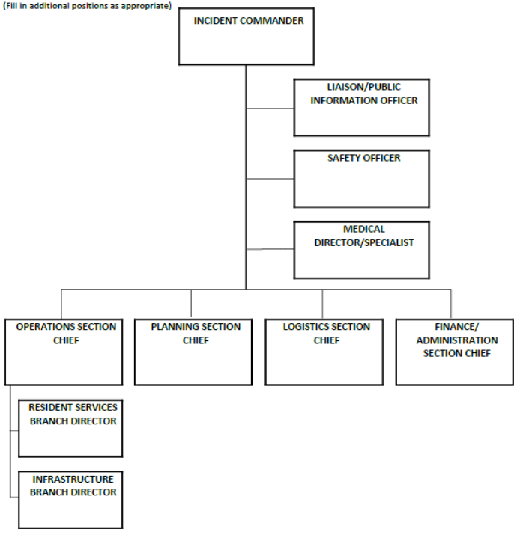

Source - http://www.cahf.org/Portals/29/DisasterPreparedness/NHICS/NHICS_E_Book.pdf

Sample Position Cross Walk

NHICS Position | Facility Position | Assigned to…
Incident Commander | Administrator
Medical Director/Specialist | Medical Director/External Clinical Specialist
Public Information Officer/Communications | Administrator or Media Relations
Operations Chief | Director of Nursing
Resident Services Director | Director of Nursing
Infrastructure Director | Maintenance Director
Planning Section Chief | Assistant Administrator
Logistics Section Chief | Designated Department Head
Finance Chief | Finance and Administrator

Incident Action Planning (IAP) Guide (FEMA IAP Guide)
During an incident/emergency, having a solid plan is key to risk mitigation and successful outcomes. The Federal Emergency Management Agency’s (FEMA) has developed a set of tools and resources that can be incorporated into a facilities overall plan, allowing for coordinate effort that is in alignment with NIMS protocols. The purpose of the Nursing Home Incident Planning Guide (IPG) is to identify issues that should be considered when planning for emergencies and unforeseen situations that may impact your nursing home. The guide helps facility leaders in identifying planning considerations during an incident including mitigation, preparedness, immediate and non-immediate responses needed as well as long term response needs and recovery.

The planning process and use of the IAP Guide is an operations activity, so should be assigned to your Operations Chief during an incident.
The incident action planning process is built on the following phases:
- Understand the situation and activate Incident Command.
- Establish incident objectives.
- Develop the plan.
- Prepare and disseminate the plan.
- Execute, evaluate, and revise the plan.

Facilities are encouraged to access the NHICS and its tools, including the customizable PDFs designed for your use. All the NHICS tools are available in this combined guide. http://www.cahf.org/Portals/29/DisasterPreparedness/NHICS/NHICS_Forms.pdf

Additional Resources
- American Health Care Association - California Department of Public Health (CDPH) and the California Association of Health Facilities (CAHF). Nursing Home Incident Command System (NHICS). 2017 Revision
http://dpapp.cahf.org/files/2015/11/NHICS-training-modules-2017-complete.pdf

- American Healthcare Association and National Center for Assisted Living (AHCA/NCAL). Shelter In Place: Planning Resource Guide for Nursing Homes. https://www.ahcancal.org/facility_operations/disaster_planning/Documents/SIP_Guideboo k_Final.pdf

- Federal Emergency Management Agency (FEMA). IS-200.HCa – Applying ICS to Healthcare Organizations. Course Summary. https://training.fema.gov/is/courseoverview.aspx?code=is-200.hca

- Department of Health and Human Services. TRAICE. Healthcare Emergency Preparedness Gateway. https://asprtracie.hhs.gov/

- Department of Health and Human Services. TRAICE. Healthcare Emergency Preparedness Gateway. Long Term Care Resources. https://asprtracie.hhs.gov/technical-resources/52/long-term-care-facilities/47

- Hospital Incident Command System – Current Guidebook and Appendices. https://emsa.ca.gov/disaster-medical-services-division-hospital-incident-command-system/

- Federal Emergency Management Agency. (2012). Incident Action Planning Guide. https://www.hsdl.org/?abstract&did=762400

