Overview of MDS 2023 Updates Toolkit-

Section 3
MDS Changes Training Plan Design and Competencies Overview

MDS Training Plan Design and Competencies – Overview

The facility training plan should include training provided for competencies and skills that correlate with the resident needs identified in the facility assessment, documentation, and Minimum Data Set (MDS) 3.0 Coding. An evaluation of the training program needs to be conducted to evaluate effectiveness of the training plan.

All training should support current scope and standards of practice through curricula which detail learning objectives, performance standards and evaluation criteria, and addresses potential risks to residents, staff, volunteers, and the facility if procedures are not followed. There should be a process in place to track interdisciplinary team participation in the required training programs.

The Centers for Medicare & Medicaid Services (CMS) outline the requirements for training, competency, and resident assessment process. It is essential for all facilities to provide training and a system to evaluate competency for quality, compliance, proper reimbursement, and to generate accurate data measures. The following CMS requirements include:

F725 Nursing Services - Sufficient Nursing Staff

“The facility must have sufficient nursing staff with the appropriate competencies and skills sets to provide nursing and related services to assure resident safety and attain or maintain the highest practicable physical, mental, and psychosocial wellbeing of each resident, as determined by resident assessments and individual plans of care and considering the number, acuity and diagnoses of the facility’s resident population in accordance with the facility assessment required at §483.70(e).”¹

F726 Nursing Services – Competent Nursing Staff

“The facility must ensure that licensed nurses have the specific competencies and skill sets necessary to care for residents’ needs, as identified through resident assessments, and described in the plan of care. §483.35(a)(4) Providing care includes but is not limited to assessing, evaluating, planning and implementing resident care plans and responding to resident’s needs.”¹

F741 Sufficient and Competent Staff – Behavioral Health Needs

“The facility must have sufficient staff who provide direct services to residents with the appropriate competencies and skills sets to provide nursing and related services to assure resident safety and attain or maintain the highest practicable physical, mental and psychosocial well-being of each resident, as determined by resident assessments and individual plans of care and considering the number, acuity and diagnoses of the facility’s resident population in accordance with §483.70(e).”

F636: Comprehensive Assessments & Timing

“The facility must conduct initially and periodically a comprehensive, accurate, standardized reproducible assessment of each resident’s functional capacity.
§483.20(b) Comprehensive Assessments §483.20(b)(1) Resident Assessment Instrument. A facility must make a comprehensive assessment of a resident’s needs, strengths, goals, life history and preferences, using the resident assessment instrument (RAI) specified by CMS. The assessment mut include at least the following:
- Identification and demographic information
- Customary routine.
- Cognitive patterns.
- Communication.
- Vision.
- Mood and behavior patterns.
- Psychological well-being.
- Physical functioning and structural problems.
- Continence.
- Disease diagnosis and health conditions.
- Dental and nutritional status.
- Skin Conditions.
- Activity pursuit.
- Medications.
- Special treatments and procedures.
- Discharge planning.
- Documentation of summary information regarding the additional assessment performed on the care areas triggered by the completion of the Minimum Data Set (MDS).
- Documentation of participation in assessment. The assessment process must include direct observation and communication with the resident, as well as communication with licensed and nonlicensed direct care staff members on all shifts.

§483.20(b)(2) When required. Subject to the timeframes prescribed in §413.343(b) of this chapter, a facility must conduct a comprehensive assessment of a resident in accordance with the timeframes specified in paragraphs (b)(2)(i) through (iii) of this section. The timeframes prescribed in §413.343(b) of this chapter do not apply to CAHs.
(i)Within 14 calendar days after admission, excluding readmissions in which there is no significant change in the resident’s physical or mental condition. (For purposes of this section, “readmission” means a return to the facility following a temporary absence for hospitalization or therapeutic leave.) ***
(iii)Not less than once every 12 months.”¹

F637 Comprehensive Assessment After Significant Change

“Within 14 days after the facility determines, or should have determined, that there has been a significant change in the resident’s physical or mental condition. (For purpose of this section, a “significant change” means a major decline or improvement in the resident’s status that will not normally resolve itself without further intervention by staff or by implementing standard disease-related clinical interventions, that has an impact on more than one area of the resident’s health status and requires interdisciplinary review or revision of the care plan, or both.)”¹

F638 Quarterly Assessment At Least Every 3 Months

“A facility must assess a resident using the quarterly review instrument specified by the State and approved by CMS not less frequently than once every 3 months.”¹

F641 Accuracy of Assessments

“The assessment must accurately reflect the resident’s status.”¹

F642 Coordination/Certification of Assessment

“§483.20(h) Coordination.
A registered nurse must conduct or coordinate each assessment with the appropriate participation of health professionals.

§483.20(i) Certification.
§483.20(i)(1) A registered nurse must sign and certify that the assessment is completed.

§483.20(i)(2) Each individual who completes a portion of the assessment must sign and certify the accuracy of that portion of the assessment.

§483.20(j) Penalty for Falsification.
§483.20(j)(1) Under Medicare and Medicaid, an individual who willfully and knowingly—
- Certifies a material and false statement in a resident assessment is subject to a civil money penalty of not more than $1,000 for each assessment; or
- Causes another individual to certify a material and false statement in a resident assessment is subject to a civil money penalty or not more than $5,000 for each assessment.
§483.20(j)(2) Clinical disagreement does not constitute a material and false statement.”¹

F655 Baseline Care Plan

“§483.21 Comprehensive Person-Centered Care Planning
§483.21(a) Baseline Care Plans
§483.21(a)(1) The facility must develop and implement a baseline care plan for each resident that includes the instructions needed to provide effective and person-centered care of the resident that meet professional standards of quality care. The baseline care plan must—
- Be developed within 48 hours of a resident’s admission.
- Include the minimum healthcare information necessary to properly care for a resident including, but not limited to—
  - Initial goals based on admission orders.
  - Physician orders.
  - Dietary orders.
  - Therapy services.
  - Social services.
  - PASARR recommendation, if applicable.

§483.21(a)(2) The facility may develop a comprehensive care plan in place of the baseline care plan if the comprehensive care plan—
- Is developed within 48 hours of the resident’s admission.
- Meets the requirements set forth in paragraph (b) of this section (excepting paragraph (b)(2)(i) of this section).

§483.21(a)(3) The facility must provide the resident and their representative with a summary of the baseline care plan that includes but is not limited to:
- The initial goals of the resident.
- A summary of the resident’s medications and dietary instructions.
- Any services and treatments to be administered by the facility and personnel acting on behalf of the facility.
- Any updated information based on the details of the comprehensive care plan, as necessary.”¹

F656 Develop/Implement Comprehensive Care Plan

“The facility must develop and implement a comprehensive person-centered care plan for each resident, consistent with the resident rights set forth at §483.10(c)(2) and §483.10(c)(3), that includes measurable objectives and timeframes to meet a resident's medical, nursing, and mental and psychosocial needs that are identified in the comprehensive assessment.”¹

F657 Care Plan Timing and Revision

“§483.21(b) Comprehensive Care Plans
§483.21(b)(2) A comprehensive care plan must be—
- Developed within 7 days after completion of the comprehensive assessment.
- Prepared by an interdisciplinary team, that includes but is not limited to—
  - The attending physician.
  - A registered nurse with responsibility for the resident.
  - A nurse aide with responsibility for the resident.
  - A member of food and nutrition services staff.
  - To the extent practicable, the participation of the resident and the resident's representative(s). An explanation must be included in a resident’s medical record if the participation of the resident and their resident representative is determined not practicable for the development of the resident’s care plan.
  - Other appropriate staff or professionals in disciplines as determined by the resident's needs or as requested by the resident.
- Reviewed and revised by the interdisciplinary team after each assessment, including both the comprehensive and quarterly review assessments.”¹

F838 Facility Assessment

“The facility must conduct and document a facility-wide assessment to determine what resources are necessary to care for its residents competently during both day-to-day operations and emergencies. The facility must review and update that assessment, as necessary, and at least annually. The facility must also review and update this assessment whenever there is, or the facility plans for, any change that would require a substantial modification to any part of this assessment.”¹

F940 Training Requirements

“A facility must develop, implement, and maintain an effective training program for all new and existing staff; individuals providing services under a contractual arrangement; and volunteers, consistent with their expected roles. A facility must determine the amount and types of training necessary based on a facility assessment as specified at § 483.70(e).”¹

INTENT OF THE TRAINING PROGRAM EVALUATION SECTION

The facility training program must include training provided for competencies and skills that correlate with the resident needs identified in the facility assessment, as well as the comprehensive assessment process. An evaluation of the training program needs to be conducted per the requirements. The overall intent of conducting an evaluation of a facility training program is to determine the effectiveness of the facility training programs and how the facility is meeting its’ objectives per the facility assessment. The evaluation is a process by which a facility can observe what they and others are doing and learn how to improve these activities when necessary.

There are numerous methods that providers may use to evaluate the progress of individual training as well as the overall outcomes of their facility training program. The intent of evaluating the training program can be conducted in two phases:
- At different stages whether daily, weekly or monthly after a specific training, which may include evaluating the individual’s response to training or the effectiveness or the training/trainer as deemed applicable and/or;
- Evaluation of the facility’s overall training program annually or as needed based upon performance outcomes which correlate with the facility assessment.

TRAINING PROGRAM EVALUATION PROCESS

Evaluating a training program is a means for a facility to gather information that can be reviewed and interpreted to make decisions regarding learning and development that aligns with standards of practice, professional scope of practice, requirements, staff knowledge and competencies and correlation with the facility assessment.
The following depicts a process to evaluate a facility training program utilizing the facility Quality Assurance and Performance Improvement process.
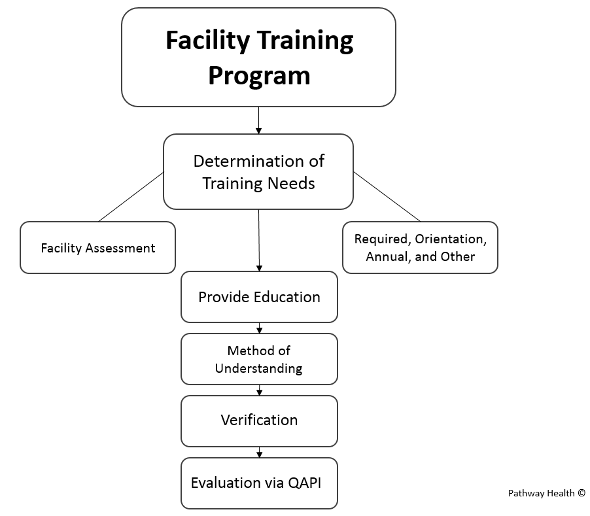
- Determination of Training Needs
  - The facility will incorporate the required training components into their orientation program, annual training plan, professional/certification requirements, facility assessment findings, as well as other clinical and operational needs.
  - Specific elements and criteria in a facility training plan should include, but not limited to:
    - Evidenced based practice
    - Standards of practice
    - Regulatory requirements (federal, state, and local)
      - CMS State Operations Manual, Appendix PP – Guidance to Surveyors for Long Term Care Facilities
      - CMS Long-Term Care Facility Resident Assessment Instrument 3.0 User’s Manual
    - Scope of practice
    - Specialty program requirements
    - Facility policies and procedures
    - Facility expectations
    - Facility assessment results
    - Staff learning needs and competencies
    - Past training needs
    - Other areas determined by operational, clinical, and organization needs

  - Additional determination of training needs includes any identified areas of deficit or opportunities for improvement based upon quality assurance and performance improvement findings

- Provide Education
  - Development of specific training/education programs should provide evidence of learning needs and overall objectives. Specific components may include, but are not limited to:
    - Training description or summary of educational content
    - Learning objectives
    - Methodology – Method of instruction such as:
      - Lecture
      - Demonstration
      - Protocol or procedure review
      - Self-Learning package
      - On-line
      - Skills Fair
      - Simulation
      - Clinical practice
      - Other
    - Handouts
    - Method of understanding to demonstrate learner knowledge post training

- Method of Understanding
  - There are numerous methods to determine a learner’s understanding of the training program, such as:
      - Written post-test
      - Oral post-test
      - Return demonstration
      - Skills check/competency check
      - Verbal review
      - Observation of performance
      - Sign in sheets verbalizing the understanding of the material
      - Other

  - There are many methods to assess knowledge and performance and a facility may choose one or a combination of methods based upon the learning objectives and process needs.

  - It is important to discuss observations and evaluations with the learner. Feedback assists the learner to see their progress and how they can improve. Acknowledge and give support for good results and provide recommendations for improvement or individualized training to achieve the expected outcomes.

- Verification or Evaluation
  - Upon the completion of individual training programs, the facility is responsible for the adherence to the training objectives – training into facility practice. There are various methods that a facility may choose to verify and validate the training objectives and facility practice, including:
    - Observation – care and practice
    - Walking rounds
    - Interviews
    - Medical record review
    - Verbal review
    - Monitoring audits
    - Annual performance evaluation

  - Document results

- Evaluation via Quality Assurance and Performance Improvement process
  - Review verification results via the QAPI process which provides the facility the opportunity to analyze and interpret data (findings) to assess performance and support improvement initiatives.
    - From the identified opportunities for improvement, the facility will systematically and objectively prioritize the opportunities in order to determine the necessary action steps. This process takes into consideration input from multiple disciplines, facility assessment findings, residents and families.

  - The facility will document its overall evaluation of individual training programs, and the overall facility training program per QAPI protocols.
    - This can be accomplished by adding the training evaluation overview and results into the QAPI Committee Meeting Minutes. This can serve as verification of your evaluation process.

The adequacy of the in-service education program may be measured not only by documentation of hours of completed in-service education, but also by demonstrated competencies of the interdisciplinary team through written exam and/or in consistently following the facility policies, procedures, and process for all aspects of the CMS guidance and best practice standards.

It is important that facilities have a training plan for the interdisciplinary team that is well planned out, comprehensive, detail oriented, identifies compliance with attendance, and includes a system for learner knowledge and competency evaluation.

References and Resources

¹Centers for Medicare & Medicaid Services. State Operations Manual, Appendix PP – Guidance to Surveyors for Long Term Care Facilities. https://www.cms.gov/medicare/provider-enrollment-and-certification/guidanceforlawsandregulations/downloads/appendix-pp-state-operations-manual.pdf

Centers for Medicare & Medicaid Services. Long-Term Care Facility Resident Assessment Instrument 3.0 User’s Manual. Version 1.18.11, October 2023: https://www.cms.gov/Medicare/Quality-Initiatives-Patient-Assessment-Instruments/NursingHomeQualityInits/MDS30RAIManual

