Overview of MDS 2023 Updates Toolkit-

Section GG Training
Post Test (IDT)

Section GG Training Post Test

Choose the most appropriate answer

Coding Key Attachment
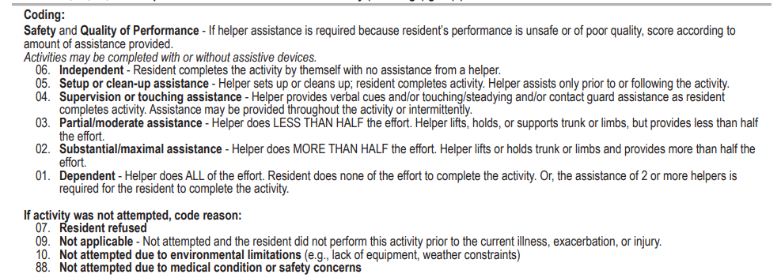
- Once a helper provides the patient/resident with a strap for their adaptive eating utensil, they can eat safely without assistance.
06- Independent
01-Dependent
03- Partial/moderate assist
05- Set up or clean up

- A patient/resident requires the assistance of two helpers to walk 10 feet.
04-Supervsion
01-Dependent
02-Substatial/maximal assist
03-Partial/moderate assist

- Due to the recent development of compression fractures, a patient/resident is on bed rest and unable to complete a bed-to-chair transfer.
01-Dependent
02-Substatial/maximal assist
09-Not applicable
88- Not attempted due to medical conditions

- A patient/resident sustained a spinal cord injury that has affected both movement and strength in both upper extremities. The patient/resident places their left hand into one-third of the left sleeve of their shirt with much time and effort and is unable to continue with the activity. A helper then completes the remaining upper body dressing for them.
04-Supervsion
01-Dependent
02-Substatial/maximal assist
03-Partial/moderate assist

- A patient/resident is required to follow hip precautions due to recent hip surgery. They require a helper to retrieve their clothing from the closet. The patient/resident uses their adaptive equipment to assist in threading their legs into their pants. Because of balance issues, the patient/resident needs the helper to steady them when standing to manage pulling on or pulling down their pants/undergarments. They also need some assistance to put on and take off their socks and shoes.
06- Independent
04-Supervision
03- Partial/moderate assist
05- Set up or clean up

- A patient/resident has multiple sclerosis, affecting their endurance and strength. They prefer to feed themself as much as they are capable. During all meals, after eating three fourths of the meal by themself, they usually become extremely fatigued and requests assistance from the certified nursing assistant to feed them the remainder of the meal
06- Independent
04-Supervision
03- Partial/moderate assist
05- Set up or clean up

- A patient/resident had bilateral amputations three years ago, and prior to the current admission they used a wheelchair and did not walk.
01-Dependent
02-Substatial/maximal assist
03-Partial/moderate assist
09-Not applicable

- Toileting hygiene consist of three elements: True or False (Circle correct answer)
- Performing perineal hygiene.
- Managing clothing (including undergarments and incontinence products, such as incontinence briefs or pads) before and after voiding or having a bowel movement.
- Adjusting clothing relevant to the individual resident.

- Patient/resident is edentulous (without teeth) and their dentures no longer fit their gums. In the morning and evening, they begin to brush their upper gums after the helper applies toothpaste onto their toothbrush. Patient/resident brushes their upper gums but cannot finish due to fatigue. The certified nursing assistant completes the activity of oral hygiene by brushing their back upper gums and their lower gums.
01-Dependent
02-Substatial/maximal assist
03-Partial/moderate assist
09-Not applicable

- Patient/resident is on bedrest due to a medical complication. They use a bedpan for bladder and bowel management.
01-Dependent
02-Substatial/maximal assist
09-Not applicable
88- Not attempted due to medical conditions

