Overview of MDS 2023 Updates Toolkit-

Subsection Section 3.4
Targeted MDS and IDT Education Templates and Recommendations

Overview: Targeted MDS and IDT Education Templates and Recommendations

Over the years, the Minimum Data Set (MDS) has evolved beyond a clinical assessment tool. It is no longer “paperwork” that any nurse can fill in. Successful completion of the MDS requires complex expertise, exposure to the nursing home environment, knowledge of the MDS coding rules, awareness of the federal nursing home regulations, deep understanding of the Medicare and Medicaid payment systems and skill in assigning and managing ICD-10-CM diagnosis codes.

Minimum Data Set (MDS) coordinators are key to nursing homes as their role oversees and implements appropriate, quality care is provided to residents by the successful completion of the MDS. They are responsible for coordinating and overseeing the interdisciplinary assessment and care planning processes for all residents in Medicare and Medicaid certified nursing homes. They play a key role in assuring the accuracy of data and information collected and used for resident outcomes, quality measures and reimbursement processes. From admission to discharge, the MDS Coordinator manages and interprets data and information needed to complete the MDS/RAI process and correlating assessments.

MDS Coordinator or Nurse Assessment Coordinator orientation, education and ongoing education is paramount to the success of this pivotal role and organizational outcomes.
To support the ongoing success of the MDS Coordinator, it is important to support and provide the following basic competencies:
- Detailed orientation or onboarding process as well as an ongoing training plan
- IDT specific training on the MDS/RAI process during orientation and ongoing – this will support the MDS Coordinator
- Detailed knowledge of correct coding rules for the MDS and Care Area Assessments
- Robust understanding of the Medicare PDPM payment classification system
- Thorough familiarity with the Official Coding Guidelines for ICD-10-CM diagnosis coding
- Command of the data used for Quality Measures, the SNF Quality Reporting Program and Value-Based Purchasing
- Exposure to the nursing home regulations and survey process
- Comprehensive skill in the use of the organization’s electronic health record

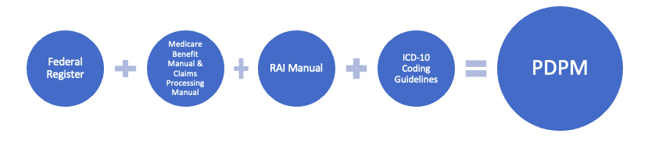

Leadership Role
Leaders need to allocate resources including time and financial resources for detailed orientation or onboarding processes as well as ongoing education for MDS/NAC Coordinators.
In addition, it is important to understand the need for MDS process education during the orientation process as well as on an ongoing basis for all Interdisciplinary team members.

This section of the Toolkit includes the following tools or resources:
- MDS/NAC Coordinator Orientation process and Competency Checklist
- Interdisciplinary Team targeted education recommendations for Section GG related to roles and responsibilities:
  - Licensed Nurse
  - Unlicensed staff
  - Therapy
  - Agency staff if applicable

While this is not an all-inclusive list of training recommendations, they are targeted towards a MDS Coordinators orientation and specific training recommendations related to roles and responsibilities of specific IDT members for Section GG.

These resources can serve as a guide/template for leaders as they continue to develop education to support the RAI/MDS process and the MDS Coordinator(s) within their organization as well as interdisciplinary team members.

References and Resources

Centers for Medicare & Medicaid Services. State Operations Manual, Appendix PP – Guidance to Surveyors for Long Term Care Facilities. https://www.cms.gov/medicare/provider-enrollment-and-certification/guidanceforlawsandregulations/downloads/appendix-pp-state-operations-manual.pdf

Centers for Medicare & Medicaid Services. Long-Term Care Facility Resident Assessment Instrument 3.0 User’s Manual. Version 1.18.11, October 2023: https://www.cms.gov/Medicare/Quality-Initiatives-Patient-Assessment-Instruments/NursingHomeQualityInits/MDS30RAIManual

