Section 1

Facility Assessment and Minimum Staffing Standards Requirements

Facility Assessment and the Minimum Staffing Standards Requirements

Based on the publication date of May 10, 2024, the Medicare and Medicaid Programs, Minimum Staffing Standards for Long-Term Care Facilities and Medicaid Institutional Payment Transparency Reporting final rule (CMS 3442-F) connects the facility assessment with the minimum staffing requirements. ¹ The Rule includes specific details related to the expansion of the facility assessment, minimum staffing requirements as well as exemptions per requirements. The illustration below outlines the key areas in the Rule.

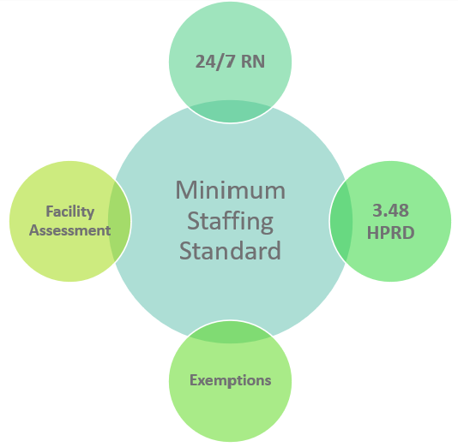

This Rule outlines the implementation of the requirements, including revised and enhanced facility assessment and minimum staffing requirements for long-term care facilities in three phases. Phase 1 is required for all facilities, regardless of their location. Phase 2 and Phase 3 implementation is staggered based upon an organization's locations (non-rural and rural as defined by the Office of Management and Budget)

- Effective date of Minimum Staffing Standards Requirements – May 10, 2024.
- Phase 1 – Enhanced Facility Assessment Requirements for all facilities (August 8, 2024)
- Phase 2 - 24/7 RN on-site requirement (implementation 2 years/3 years)
- Phase 2 - Total Nurse Staffing HPRD requirement (3.48 Total Nursing Staffing HPRD) (implementation 2 years/3 years)
- Phase 3 - RN/NA minimum staffing HPRD (.55 RN and 2.45 NA HPRD) (implementation 3 years/5 years)
- Medicaid payment transparency (implementation 4 years)

With Phase 1 implementation, F838³ requirements were updated to include the below key areas:
- Creates a new regulatory section for the facility assessment at §483.71 F838 (separating from the Administration section of the State Operations Manual³)
- Requires facilities to develop and maintain staffing plans to maximize recruitment & retention of nursing staff
- The facility should address staffing for all shifts and days of the week and adjust based on significant changes in the resident population
- Requires facilities to use the facility assessment to assess the specific needs of each resident unit in the facility and to adjust as necessary based on any significant changes in the resident population.
- Facilities must use evidence-based data-driven methods that consider the resident condition, linked to resident assessment –
  - The facility must use evidence-based methods when care planning for their residents, including consideration for those residents with behavioral health needs.
  - Behavioral health issues and staff skill sets are emphasized throughout the Rule
- Requires greater inclusion of direct care staff in development, including representatives of direct care employees (union, local safety organization, third-party worker advocacy group)
  - What that means that the new rule requires that facilities include the input of the nursing home leadership, including but not limited to a member of the governing body and the medical director; management, including but not limited to an administrator and the director of nursing; and direct care staff, including but not limited to RNs, LPNs/LVNs, and NAs.
  - The facility must also solicit and consider input received from residents, resident representatives, family members, and representatives of direct care staff.
- Facilities must develop a contingency plan for non-emergency events that have the potential to affect resident care

The facility assessment has three main components including the assessment of the facility resident population, the necessary resources including personnel as well as the identification of risks per an all-hazards approach. These details are outlined in requirements.^{1, 2, 3}

The Facility Assessment Toolkit

The Facility Assessment Toolkit has been updated to include the revised guidance and is designed to assist leaders and their teams with tools, templates, leaders’ guidance, and resources to conduct the facility assessment with their team and determine the necessary resources and support to provide care and services to the organization’s residents. Leaders can select which tools and templates that work best for their organization.

References and Resources

¹Medicare and Medicaid Programs, Minimum Staffing Standards for Long-Term Care Facilities and Medicaid Institutional Payment Transparency Reporting final rule (CMS 3442-F). May 10, 2024. https://www.federalregister.gov/documents/2024/05/10/2024-08273/medicare-and-medicaid-programs-minimum-staffing-standards-for-long-term-care-facilities-and-medicaid

²Centers for Medicare & Medicaid Services. QSO Memo 24-12-NH. June 18, 2024. https://www.cms.gov/files/document/qso-24-13-nh.pdf

³Centers for Medicare & Medicaid Services. State Operations Manual, Appendix PP – Guidance to Surveyors for Long Term Care Facilities: https://www.cms.gov/medicare/provider-enrollment-and-certification/guidanceforlawsandregulations/downloads/appendix-pp-state-operations-manual.pdf

