Section 16

QAPI Program Plan -
TEMPLATE

QUALITY ASSURANCE PERFORMANCE IMPROVEMENT PROGRAM

Preface

The Centers for Medicare & Medicaid Services (CMS) identifies that the intent of the QAPI program is, “to ensure that long-term care facilities (including multi-unit chains) implement a comprehensive QAPI program which addresses all the care and unique services a facility provides.”¹

“Quality Assurance (QA)” is the specification of standards for quality of service and outcomes, and systems throughout the organization for assuring that care is maintained at acceptable levels in relation to those standards. QA is on-going, both anticipatory and retrospective in its efforts to identify how the organization is performing, including where and why facility performance is at risk or has failed to meet standards.”¹

“Performance Improvement (PI)” (also called Quality Improvement – QI) is the continuous study and improvement of processes with the intent to improve services or outcomes, and prevent or decrease the likelihood of problems, by identifying areas of opportunity and testing new approaches to fix underlying causes of persistent/systemic problems or barriers to improvement. PI in nursing homes aims to improve processes involved in health care delivery and resident quality of life. PI can make good quality even better.”¹

“Quality Assurance and Performance Improvement (QAPI)”: is the coordinated application of two mutually-reinforcing aspects of a quality management system: Quality Assurance (QA) and Performance Improvement (PI). QAPI takes a systematic, interdisciplinary, comprehensive, and data-driven approach to maintaining and improving safety and quality in nursing homes while involving residents and families, and all nursing home caregivers in practical and creative problem solving.”¹

Regulations require that a facility’s QAPI program be ongoing, comprehensive and address the full range of care and services provided by the facility. The program must address all systems of care and management practices. The program utilizes the best available evidence to define and measure indicators of clinical care, quality of life, resident choice. The facility’s goals reflect care processes and facility operations that have been shown to be predictive of desired outcomes for residents of SNFs and NFs. The program reflects each facility’s complexities, unique residents and care and services provided.
A comprehensive QAPI program involves all staff. Residents and residents’ representatives are knowledgeable of the facility’s QAPI activities.

Additional Definitions from the CMS State Operations Manual:

“Corrective Action”: A written and implemented plan of action for correcting or improving
performance in response to an identified quality deficiency. Use of the term corrective action in
this guidance is not synonymous with a Plan of Correction (formal response to cited
deficiencies). This is also separate from the written QAPI plan.”¹

“Quality Deficiency (or Opportunity for Improvement)”: A deviation in performance resulting in an actual or potential undesirable outcome, or an opportunity for improvement. A quality deficiency is anything the facility considers to be in need of further investigation and correction or improvement. Examples include problems such as medical errors and accidents, as well as improvement opportunities such as responses to questionnaires showing decreased satisfaction. This term is not necessarily synonymous with a noncompliance deficiency cited by surveyors, but may include issues related to deficiencies cited on annual or complaint surveys.”¹

“High-risk areas”: Refers to care or service areas associated with significant risk to the health or
safety of residents. Errors in these care areas have the potential to cause adverse events resulting in pain, suffering, and/or death. Examples include tracheostomy care; pressure injury prevention; administration of high-risk medications such as anticoagulants insulin, and opioids.”

“High-Volume areas”: Refers to care or service areas performed frequently or affecting a large
population, thus increasing the scope of the problem, e.g., transcription of orders; medication
administration; laboratory testing.”¹

“Performance Improvement Projects (PIPs)” “are a process that generally involves a team making a concentrated effort over time to improve a systemic problem or improve quality in absence of a problem. PIPs often require a systematic investigation, such as a Root Cause Analysis (RCA) to identify underlying causes or factors which have contributed to or caused the problem and the development of a corrective action plan. Interventions are designed to address the underlying causes, and once implemented, the team closely monitors results to determine if changes are yielding the expected improvement or if the interventions should be revised.”¹

“Problem-prone areas”: Refers to care or service areas that have historically had repeated problems, e.g., call bell response times; staff turnover; lost laundry.”¹

“Systematic”: describes a step by step process that is structured, so that it can be replicated.”

“Systemic”: embedded within, and affecting a system or process.”¹

Sample

ABC Facility
Quality Assurance/Assessment and Performance Improvement Plan

Purpose
Example: The purpose of the Quality Assurance/Assessment and Performance Improvement (QAPI) Program is to utilize a systematic, interdisciplinary, comprehensive, on-going, data driven, and pro-active approach to advance the safety, quality of life and quality of care for all residents at ABC Facility. Quality Assurance and Performance Improvement principles will drive our facility’s decision to make and promote excellence in all resident and staff-related areas. All facility staff, families and residents will be encouraged to be involved in identifying opportunities for improvement, partake in QAPI teams, embed QAPI activities in all core processes and provide ongoing feedback. There will be a process for ongoing continuous evaluation of the facility systems for consistent implementation of accurate, current, and evidence-based practices.

Mission
Example: To provide superior quality health care services and to be the facility of choice where our residents see themselves not as patients but rather as members of our extended family

Vision
Example: To be recognized leaders for excellence in healthcare with innovative services for improved resident outcomes.

Guiding Principles
Guiding Principle #1: Our organization makes quality improvement decisions based on data analysis with input from residents, families, staff and the community
Guiding Principle #2: Our organization uses quality assurance and performance improvement (QAPI) principles to address systems of care
Guiding Principle #3: In our organization, …
Guiding Principle #4:
Guiding Principle #5:

Design and Scope
Each facility’s program will be on-going, comprehensive, interdisciplinary, including monitoring important management practices, and reflect the resident population, staff community, care and the full range of care and services provided by the facility and the resources available and reflect the Service Standards of ABC Facility. The QAPI program will:
- “Address all systems of care and management practices;
- Include clinical care, quality of life and resident choice;
- Utilize the best available evidence to define measure indicators of quality and facility goals that reflect processes of care and facility operations that have been shown to be predictive of desired outcomes for residents; and
- Reflect the complexities, unique care and services that the facility provides.”¹

Example: The QAPI program at ABC Facility encompasses post-acute care, long term care and outpatient therapy. The QAPI committee consists of representatives from all departments including nursing, food and nutrition, laundry, maintenance, health information technology, therapeutic recreation, therapy, business office and administration. Involvement will be varied by topic and may include committee, sub-committee, or verbal/written input. Our service areas will work together to best meet the needs of the individuals living in our care center. All departments and services along with families, residents, volunteers, board members and contract staff will be educated on the principles of QAPI. All resident directed decisions will be focused on retaining autonomy, encouraging individualized choices, and preserving the highest attainable quality of life and quality of care. The facility will seek ongoing resident feedback. PIPs will be implemented when an opportunity for improvement is identified. These PIPs may apply to processes or systems at all levels of the organization.

The QAPI program is ongoing, comprehensive and addresses the full range of care and services provided at ABC Facility.

Clinical Care – example: data will be obtained from the following reports: QI/QM, infection, medication error, pressure injuries, falls, health department surveys, CASPER and pain. Licensed nursing staff will receive up-to-date education on best practice and clinical guidelines to promote the highest attainable level of clinical care. The team will meet monthly with the Medical Director to achieve desirable outcomes for the residents. Results will be shared with the QAPI Steering Committee on a quarterly basis.
Quality of Life - example: the best available evidence will be utilized to define and measure indicators of quality including but not limited to resident and family satisfaction surveys, resident council meetings, health department surveys and grievances/concerns. The team will meet monthly to review findings and concerns and prioritize activities. Results will be shared with the QAPI Steering Committee on a quarterly basis.

Resident Choice – example: individualized plans of care are developed with input from residents and family members. Plans of care are reviewed at care conferences and choices are offered with care options throughout the day. Residents or resident representatives are encouraged to direct their clinical care with staff member guidance to assure safety and informed decision making.

ABC Facility is unique in the population served as we have a ventilator unit with medically complex residents requiring nursing staff with specialized training. Education and competency training are performed on a regular basis. Other service areas include memory care, short term rehab, long term care, hospice, and respite care.

The services available at ABC Facility include:

Skilled Nursing  Long-Term Care  Post-acute care  Dialysis  Hospice/Palliative Care  Pharmacy | Therapy  Outpatient  Physical  Occupational  Respiratory  Speech Language pathology  Alzheimer's/Memory Care  Skilled Rehabilitation
Dietary  Dining  Dietitian  Activities | Social Services  Care Coordination  Mental Health
Housekeeping  Laundry  Janitorial | Maintenance  Building  Landscaping/Grounds keeping  Equipment
Health Information Services  Electronic Health Record  Electronic Medical Record  Minimum Data Set | Business Office  Staffing  Billing  Human Resources

Organizational Resources include:

Staff Education
On-line LMS
On-boarding and Orientation
Internal Continuing Education
External Continuing Education, (Conferences, Symposiums, etc.)

Governance and Leadership
Example: The Nursing Home Administrator (NHA) and Board of Directors are responsible, and accountable and assume full authority and responsibility of the program to include the development, implementation, and monitoring of the QAPI program. The Governing Body will make sure that the program:
- “Is defined, implemented and ongoing;
- Addresses identified priorities;
- Is sustained through transitions in leadership and staffing;
- Has adequate resources, including staff time, equipment, and technical training as needed;
- Uses performance indicator data, resident and staff input, and other information to identify and prioritize problems and opportunities;
- Implements corrective actions to address gaps in systems and evaluates actions for effectiveness; and
- Establishes clear expectations around safety, quality, rights, choice and respect.”¹

The Governing Body will also make sure that:
- The Quality Assessment and Assurance (QAA) Committee consists of the Director of Nursing Services, the Medical Director, the Administrator, at least two other members of the facility staff, and the infection control and prevention officer.
- The QAA Committee meets at least quarterly to coordinate and evaluate the activities under the QAPI program.
- A QAPI Steering Committee is appointed by the NHA and the Executive leadership team and is interdisciplinary with at least two non-licensed staff who provide direct care or service to the residents. This may include nursing assistants, food and nutrition staff, housekeeping staff, maintenance, and laundry staff.
- Non-licensed staff will serve on the Committee for one year and then rotate out, so additional staff have the opportunity to serve on the Committee.
- The QAPI Steering Committee, which includes the Medical Director as co-chair, meets monthly and is accountable for the continuous improvement in Quality of Life and Quality of Care. Minutes are recorded and shared with staff verbally and posted in staff areas for review.
- The QAPI Steering Committee collects data from sub committees (pain, falls, weight loss) and includes the data in their quarterly reports to the QAA Committee /NHA/Board of Directors.
- The QAA Committee completes an annual assessment of the program with report to the governing body/Board of Directors.
- A Quality Management Coordinator is appointed by the NHA and Executive Leadership team and is responsible for ongoing QAPI activities including development of a facility dashboard to display current goals and progress toward those goals.
- On a quarterly basis, the NHA will report on all current QAPI activities and outcomes to the Board of Directors.
- Annually, Executive Leadership will report on the status of the current QAPI plan and outline plans for the upcoming year. This information will be shared with the Board of Directors, management team, staff, and resident/family councils.
- The Executive Leadership team will support and advise the QAPI Steering Committee.

Budget: The Nursing Home Administrator works with the Board of Directors to create a budget for QAPI to assure that resources are available for the ongoing activities of the QAPI Committee. Resources include but are not limited to time for education, staff time for meetings, equipment, technology needs, software, supplies, improvement projects, etc.

Education: All staff, including contracted staff are educated on the principles of QAPI. QAPI is included in the orientation of new employees and in the annual education that all staff are required to attend. Education can include the use of visual aide tools, posters, pay-check stuffers, text alerts, small group exercises, department meetings, all staff meetings, change of shift reports, facility newsletter, etc. Staff will be trained in using QAPI principles, identifying areas for improvement, and how they can be involved in the QAPI process including participation on a PIP team. The QAPI program is sustained during transitions in leadership and staffing through all-staff education and involvement in the QAPI process.
Residents and families are also informed of the QAPI plan and are encouraged to share their insights, concerns, and opportunities for improvement. QAPI will be discussed at resident council meetings and family council meetings. Involvement of residents and family members on a PIP team may be considered.

Culture: ABC Facility believes in providing a non-punitive environment where managers encourage all staff involvement in bringing forward concerns, areas for improvement, reporting mistakes, and reporting quality issues. Managers will respond respectfully and timely to maintain an environment where staff have no fear of reprisal.

Feedback, Data Systems, and Monitoring
Example: ABC Facility will monitor multiple data sources and performance indicators in determining areas of concern, gaps and opportunities and also to determine effectiveness of system modifications and other interventions. All data will be reviewed against state, national or organization benchmarks or thresholds as appropriate and will be reported to the Board of Directors on a quarterly basis.

Data for adverse events and medical errors will be tracked, causes analyzed, and preventative actions and mechanisms put into place. Feedback will be provided to staff and education provided as needed.

Potential sources of data may include:
- Survey outcomes
- Chart review/audit
- Complaints
- Near misses
- Input from staff, residents, families and volunteers
- CMS Quality Measures
- Medication Errors
- Rehospitalization Rates
- Staff hours per day
- Staff retention
- Case Mix findings
- Pharmacist reports
- CASPER report
- Behavioral Health reports
- Satisfaction survey and questionnaire outcomes
- Suggestion or comment boxes
- Meeting feedback (i.e., care plan, resident council, family council, safety, town hall, etc.)
- Billing audits
- Five Star report

Data may be collected weekly, monthly, or quarterly depending on frequency of data updates from each source. The QAPI Management Coordinator oversees the maintenance of the QAPI dashboard, monthly reports/graphs, QAPI logs, and minutes of all meetings. The QAPI Steering Committee may utilize CMS’s Measure/Indicator Development worksheet and CMS’s Measure/Indicator Collection and Monitoring Plan to assist with program development.
(Insert facility-specific table here with data sources, frequency of data collection, who reviews the information, and how the information is disseminated.)

Performance Improvement Projects (PIPs)
Example: ABC Facility will review the designated sources of data; identify areas where gaps in performance may negatively affect resident or staff outcomes. Where opportunities for improvement are detected, the QAPI Steering Committee with input from the Leadership Team will prioritize focus areas for PIP development. In prioritizing activities, the team will consider:
- high-risk to residents and/or staff,
- high-volume or problem-prone areas,
- health outcomes,
- resident safety,
- resident autonomy,
- resident choice,
- cost,
- feasibility,
- relevance,
- responsiveness,
- areas not outside of benchmarks but of importance to the resident population we serve.

The CMS publication Prioritizing Worksheet for Performance Improvement Projects may be utilized to assist with prioritizing potential areas of concern.

At least annually a project that focuses on high-risk or problem-prone areas will be addressed through the QAPI program including PIP development. As defined in the facility assessment required at §483.70(e) our facility’s services and resources will be taken into account when determining how many PIPs to support at one time. A minimum of one PIP and a maximum of four PIPs will occur simultaneously.

A project charter that establishes the goals, scope, timing, milestones, and team’s roles and responsibilities will be developed for each PIP. CMS’s form, Worksheet to Create a Performance Improvement Project Charter may be utilized by the QAPI Steering Committee to provide guidance to the PIP team.

The PIP team will be assembled by the QAPI Steering Committee and the QAPI Quality Manager. The team will be interdisciplinary with staff representing each job role affected by the project and may include resident and/or family representation when appropriate. Direct care staff will be replaced at their workstation so that resident care is not interrupted. A project lead will be selected and will be responsible for coordinating, organizing, and directing the activities of that specific PIP team.

The PIP Team will identify the information needed to evaluate the problem at hand, supplies required, staff participation, and any equipment needs. The project lead will communicate any identified resource needs to the QAPI Quality Manager. The team will utilize root cause analysis to identify the cause of the problem and any contributing factors. PDSA will also be used and is further described in the next section – Systematic Analysis and Systemic Action. The PIP team will develop an action plan with the identified problem statement, causes, goals, interventions, staff responsible, and due dates.

The following forms may be utilized for PIP Action Plans:
(Insert facility-specific form here)
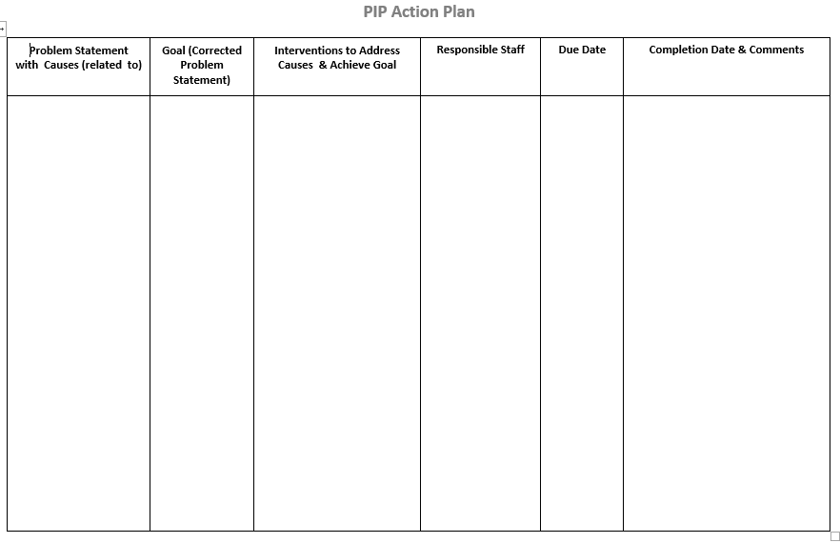

The following form may be utilized in developing and monitoring Action Plans:
(Insert facility-specific form here)
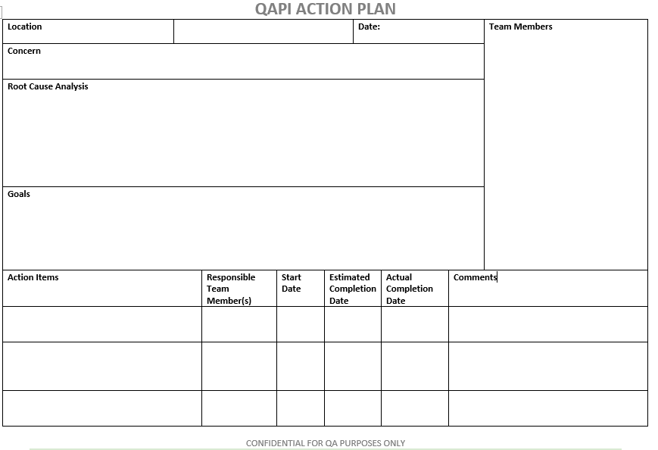

PIP activities will be reported to residents, families, and staff at least one time during the PIP. More frequent communication may be required as determined by the QAPI Quality Manager. Communication may occur via posters, bulletin boards, newsletters, and/or meetings with residents, family, staff, and board members. To monitor the status of PIPs within our building, we will utilize CMS Performance Improvement Project (PIP) Inventory.

The project lead will also provide verbal and written documentation at the monthly QAPI Committee meetings. Meeting minutes will include information shared.

Systematic Analysis and Systemic Action
Example: ABC Facility uses a systematic approach to determine the root cause of an issue and any contributing factors. Facility staff and management have been trained on Root Cause Analysis. The PIP team identifies the root cause through the utilization of many different tools, including:
- Fishbone Diagram
- Five Whys
- Cause and Effect Diagram
- Healthcare Failure Mode and Effect Analysis (HFMEA)

The team considers the implications of any interventions, changes to systems for potential negative outcomes in other areas or corrective actions necessary to prevent quality of care, quality of life or safety problems. The team will determine whether a pilot test or facility-wide change is appropriate based on the facts gathered.

We utilize Plan-Do-Study-Act (PDSA) as our rapid-cycle improvement strategy with outcomes reported ongoing to the QAPI Quality Manager and quarterly to the QAPI Steering Committee.
Each PIP team determines the timing for the conduction of periodic measurements and reviews to evaluate whether new actions/interventions are being followed/performed consistently in order to ensure that improvements are sustained. If any backsliding has occurred, the team will continue with the PDSA cycle with changes in processes/procedures as required.

Evaluation
The QAPI program will be evaluated annually by the QAPI Steering Committee with input from the Leadership Team/Executive Leadership. This review will include whether goals were met if standards of practice are being followed, any training needs will be identified and addressed, and staff opinion on the QAPI process will be obtained via survey. Current trends in long-term care will be considered along with strategic plans for ABC Facility. Any variances in systems and processes will be identified and included in the coming year’s QAPI plan.
This plan was established on (insert date) and will be revisited and revised as needed annually at a minimum.

References and Resources:

- ¹ Centers for Medicare and Medicaid Services. State Operations Manual, Appendix PP, Guidance to Surveyors for Long Term Care Facilities: https://www.cms.gov/medicare/provider-enrollment-and-certification/guidanceforlawsandregulations/downloads/appendix-pp-state-operations-manual.pdf
- Medicare and Medicaid Programs, Minimum Staffing Standards for Long-Term Care Facilities and Medicaid Institutional Payment Transparency Reporting final rule (CMS 3442-F). May 10, 2024. https://www.federalregister.gov/documents/2024/05/10/2024-08273/medicare-and-medicaid-programs-minimum-staffing-standards-for-long-term-care-facilities-and-medicaid

- “Process Tool Framework” link: https://www.cms.gov/Medicare/Provider-Enrollment-and-Certification/QAPI/Downloads/ProcessToolFramework.pdf

- “QAPI Self-Assessment Tool”, located at: https://www.cms.gov/Medicare/Provider-Enrollment-and-Certification/QAPI/downloads/QAPISelfAssessment.pdf

- The first QAPI News Brief, Volume 1: https://www.cms.gov/Medicare/Provider-Enrollment-and-Certification/QAPI/Downloads/QAPINewsBrief.pdf

- QAPI News Brief Volume 2: https://www.cms.gov/Medicare/Provider-Enrollment-and-Certification/QAPI/Downloads/QAPI-Newsbrief-Volume-2.pdf

- Centers for Medicare and Medicaid Services. QAPI Website: https://www.cms.gov/Medicare/Provider-Enrollment-and-Certification/QAPI/NHQAPI.html

- Centers for Medicare and Medicaid Services, Form CMS-20058 Quality Assurance & Performance Improvement (QAPI) and Quality Assessment & Assurance (QAA) Review: https://www.cms.gov/files/zip/survey-resources.zip

- Centers for Medicare & Medicaid Services. Measure/Indicator Development Worksheet. https://www.cms.gov/Medicare/Provider-Enrollment-and-Certification/QAPI/downloads/MeasIndicatDevWksdebedits.pdf

- Centers for Medicare & Medicaid Services. Measure/Indicator Collection and Monitoring Plan: https://www.cms.gov/Medicare/Provider-Enrollment-and-Certification/QAPI/downloads/MeasIndCollectMtrPlandebedits.pdf

- Centers for Medicare & Medicaid Services. Prioritizing Worksheet for Performance Improvement Projects. https://www.cms.gov/Medicare/Provider-Enrollment-and-Certification/QAPI/downloads/PIPCharterWkshtdebedits.pdf

- Centers for Medicare & Medicaid Services. Worksheet to Create a Performance Improvement Project Charter: https://www.cms.gov/Medicare/Provider-Enrollment-and-Certification/QAPI/downloads/PIPCharterWkshtdebedits.pdf

- Centers for Medicare & Medicaid Services. Performance Improvement Project (PIP) Inventory. https://www.cms.gov/medicare/provider-enrollment-and-certification/qapi/downloads/pipinventorydebedits.pdf

